Immigrant Experience Simulation
Task: You must follow the instructions below explicitly. This activity will be counted as a PRODUCT GRADE! Points will be taken off for not following instructions. Failure to participate in the activity will result in a zero for the assignment.
- With your group, tape out a square of 7 feet by 7 feet.
  - This will be your ‘home’ for the class period
    - Why? Immigrants at the turn of the 20th century (early 1900s) lived in very tight quarters for which they had no choice
- You and your group members are to stay in your square
- Work with your group members to complete the Urban Living notes, using the packet given to you by your teacher once your ‘home’ is set up
  - Make sure that everyone has the notes completed before moving on
    - Why only one packet? This will demonstrate what it was like for poor immigrant families to work together and rely on one another when they only had limited supplies
- After you are done with the notes, have one group member turn it back into your teacher. You will then receive a family profile that you need to complete. Make sure all of the group members’ names are on the front page of the packet!
  - You should be working on the whole packet as a group, but each person should take turns in completing at least one page of the packet. Make sure to write at the top of each page who is completing that section where it states “Completed By: ________”
- Before returning back to class, your group will have to peel up any tape from the floor. NO TAPE is to be left on the floor whatsoever!

Urban Living: The Immigrant Experience at the Turn of the 20th Century

Key Vocabulary
Urbanization: the process of making an area more urban
Assimilation: to absorb into the cultural tradition of a population or group the community assimilated many immigrants
Ethnic Neighborhood: an area with a much higher concentration of a particular ethnic or cultural group that doesn’t dominate in the general population
Tenement House: a house divided into and rented out as separate residences, especially one that is run-down and overcrowded
***************************************

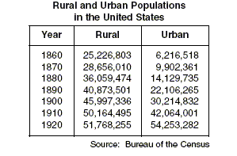

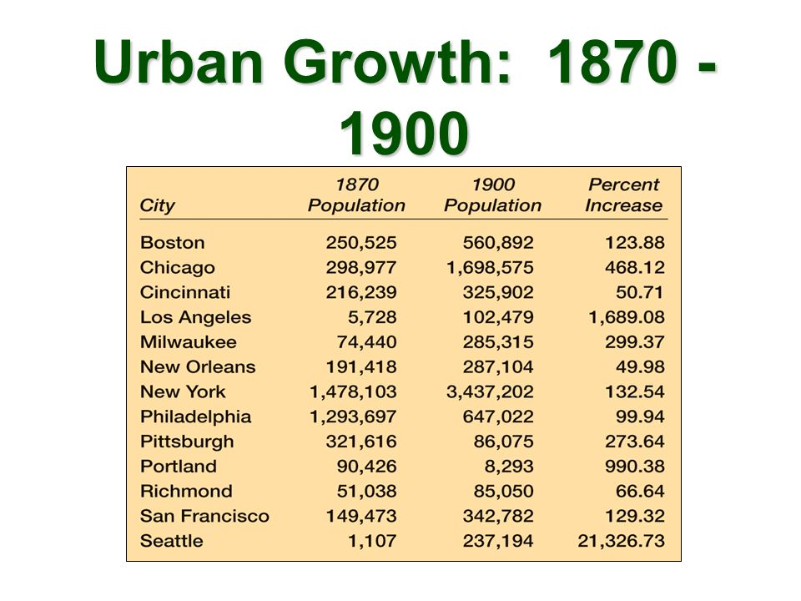
**************************************
Assimilation:
When immigrants came over to the United States, they faced many new challenges with establishing a new life. One challenge was becoming accustomed with American cultural traditions. Over time, immigrants would assimilate to American culture while still maintaining aspects of their heritage. Examples of assimilation included, but were not limited to, learning how to speak English, celebrating American holidays, and following traditional American sports, such as baseball. However, maintaining their individual cultural heritage was still important, such as ways of celebrating Christian holidays (example: Italian Catholics celebrate Christmas differently than Christmas is celebrated in the United States), speaking their native language in their neighborhoods, and dancing to ethnic music.
***************************************

Examples of ethnic neighborhoods:
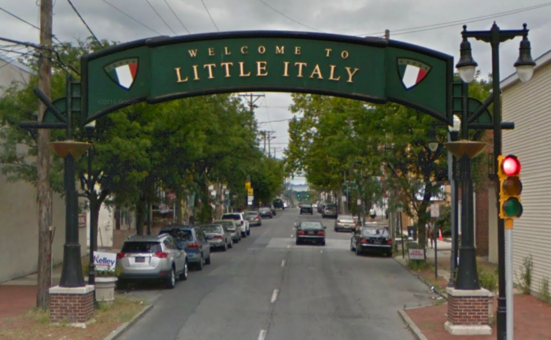
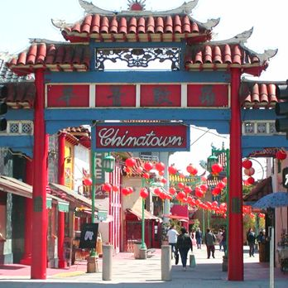
New York’s Lower East Side
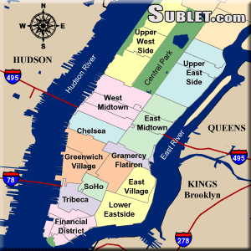 Many poor immigrants of the third wave settled in New York’s Lower East Side due to cheap rent and the establishment of tenement house apartments.
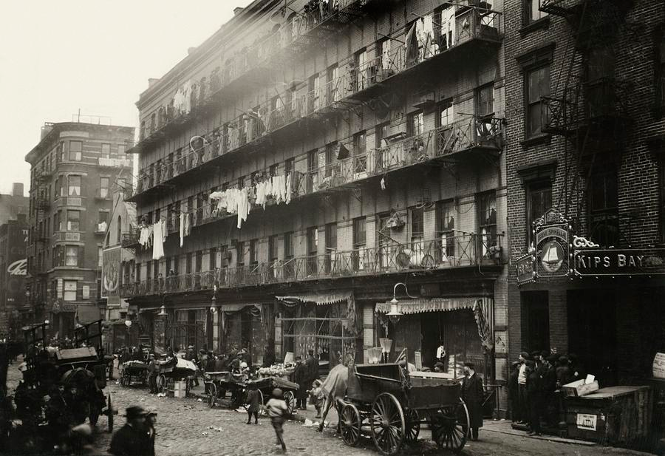
Tenement apartment building, 1912
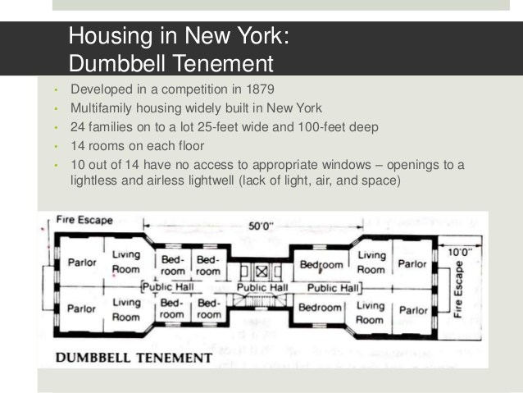

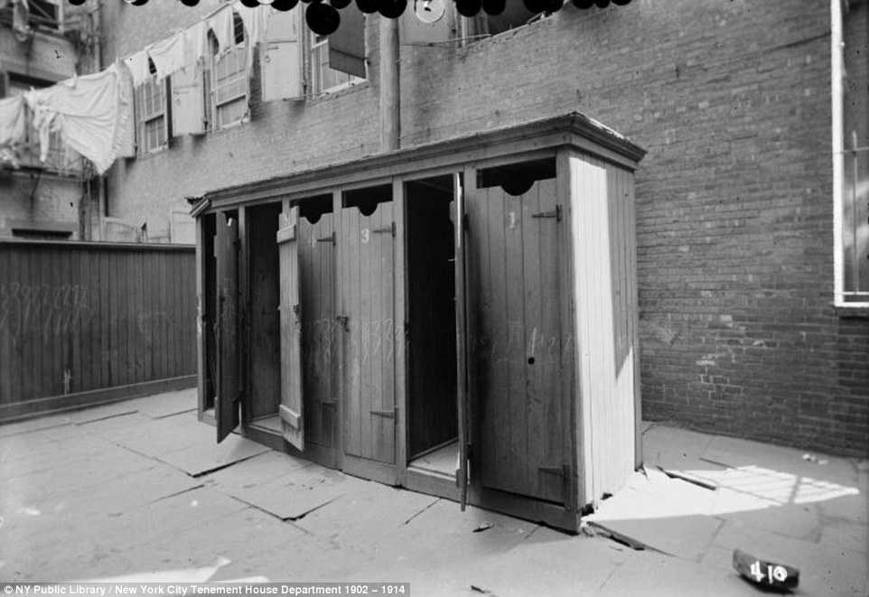 A row of outhouses for an entire apartment building (no indoor plumbing)
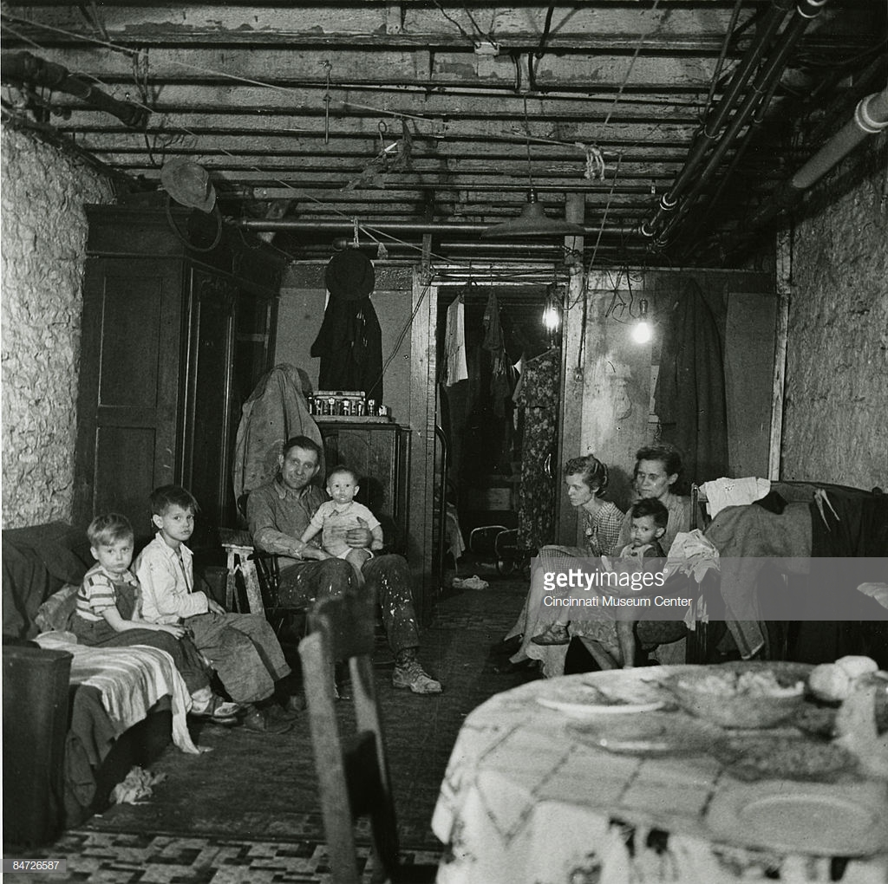
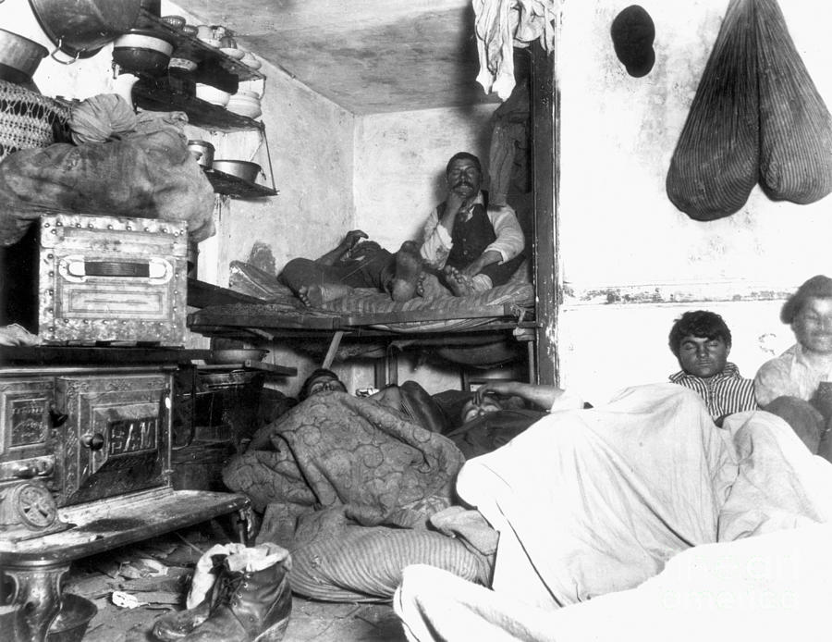
At least 6 men had to share one tiny room in their apartment in the Lower East Side
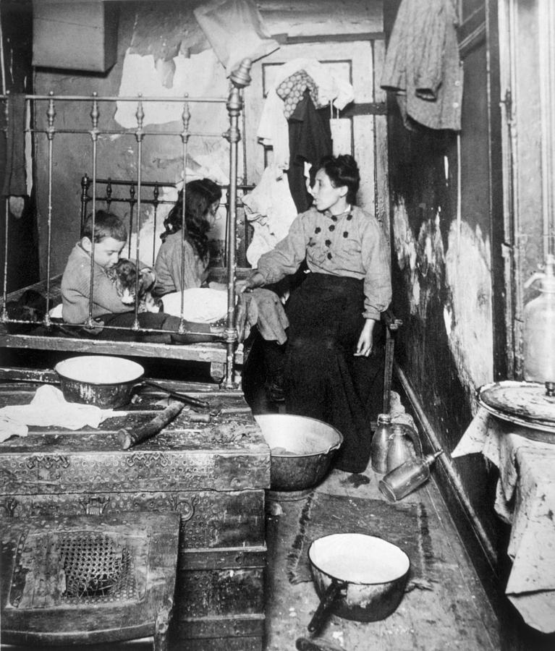
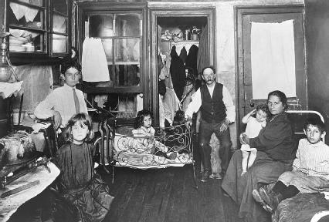 This living room also served as a kitchen and the children’s bedroom. The parents converted the closet you see in the picture as their bedroom.
Urban Living: The Immigrant Experience at the Turn of the 20th Century

Define the key vocabulary terms below

Urbanization
Assimilation
Ethnic Neighborhood
Tenement House

Analyze the “Rural and Urban Populations in the United States” table and answer the questions below.

- What type of area did the majority of the American population live in 1860?

- What type of area did the majority of the American population live in 1890?

- How is this an example of urbanization?

Study the “Urban Growth” table and answer the questions below.
- Which city had the highest population in 1900?

- What other two cities had the highest populations in 1900?

- Which city had the highest increase of population percentage from 1870-1900?

- Why do you think so many people were moving to cities between 1860 & 1900?

Read through the short passage on Assimilation and answer the questions below.
- What were some examples of assimilation?

- How could immigrants still maintain aspects of their native culture?

Study the pictures depicting examples of ethnic neighborhoods.
- What are some examples of ethnic neighborhoods?

- What would you expect to see in an ethnic neighborhood?

Analyze the photographs of the tenement houses in New York’s Lower East Side.
- Why did many immigrants settle in New York’s Lower East Side?

- Describe the conditions of the tenement housing buildings IN DETAIL (record at least one bullet for each image)

Group Members’ Names: ____________________________________________________________

Page One Completed By: ________________________________

Family Profile
Your family is among the millions of poor immigrant families that decided to move to the United States for a better life during the 3rd wave of immigration.
Which country has your family immigrated from (it can be any country in the world!)

Names and ages of family members (MUST include a father, mother, and at least two children—but can be more! Many families had four or more children!):

What push factors made you want to move out of your home country? (List at least two)

What pull factors made you want to move to America? (List at least two)

Your family had to sell most of your belongings in order to be able to afford tickets on the steamship. Besides one suitcase each of clothes, you can only bring five other items to fit in one more suitcase. What will those five items be?

Describe the passage over on the steamship across the Atlantic Ocean in 3 bullets:

Page Two Completed By: _________________________________________

What city have you decided to settle in? Circle one
New York City Chicago Philadelphia Boston Pittsburgh
Atlanta New Orleans Baltimore Providence Detroit

What are the biggest problems you face now that you have moved to America? List three

The husband finds a job working in a factory that does not allow unions. How much money will he make a week?

The wife finds a job working in a factory that does not allow unions. Women also get paid less than men. How much money will she make a week?

Which of the children will have to work? How much will they make a week?

Add the amounts you recorded above and multiple the sum by 4. This is the total that your family will make in one month. What is the amount?

Rent costs $5 for the month. Food costs $10 for the month. Transportation to work costs $2 for the month. Add this up and subtract it from the amount of money your family makes in one month. How much money do you have left over?

Page Three Completed By: ________________________________________

Oh no! One of your children is sick! One of the parents has to stay home from work for one week! Which parent will stay home? Why?

Medicine for your sick child costs $5. Based on the amount you have left over for the month (indicated in the last question on the 2nd page), can you afford the medicine?

Your neighbor’s dog just had puppies and is trying to sell them once they are big enough to leave home. Your other child wants a puppy. Will you buy one of your neighbor’s puppies? Why/why not?

Describe what it is like to live in a tenement house.

Describe what it is like to live in a tenement neighborhood.

The husband’s coworkers want to start a union at the factory, even though the boss says he will fire anyone who attempts to unionize. The workers want the husband to join in on a strike. What decision does he make? Why?

Page Four Completed By: ________________________________________

Draw a layout of the inside of your family’s apartment. There should not be any indoor plumbing and needs to be at least one bedroom. How many bedrooms, if any, will the apartment have? Will there be a window?

Page Five Completed By: ________________________________

It’s time for Sunday night dinner! Make a list of food that the wife will need to buy at the markets to make a delicious, yet affordable, dinner. Your apartment has an icebox, stove, and oven. Make your decision based on the food and prices listed below. Keep in mind that your family needs money for food for the rest of the week, so while you want to make a nice dinner, you still need to save money, too.
Whole Chicken: $0.20/pound
Ham: $0.20/pound
Steak: $0.25/pound
Pork chops: $0.40/pound
Loaf of bread: $0.07
Bushel of potatoes: $0.61
Butter: $0.12/pound
Rice: $0.10/pound
Carrots: $0.25/pound
Green beans: $0.20/pound
Quart of milk: $0.10

What will you buy and in what quantities? Make sure to consider the total price of the meal!

