Late 19th Century Document Analysis
Directions: Attached to this handout is a set of documents related to the following question: “Assess the validity of this statement: During the late 19th century, the federal government promoted the interests of wealthy Americans but failed to protect the rights of ordinary Americans.” Pick 6 of those 8 documents and complete the chart below.

Doc | Paraphrase the Document (One Complete Sentence) | Did the government help the wealthy but not other Americans? (Yes or No)?
 | In this document,
 | In this document,
 | In this document,
 | In this document,
 | In this document,
 | In this document,

Document A: Excerpt from An Act to secure Homesteads to Settlers on the Public Domain, 1862
Be it enacted by the Senate and House of Representatives of the United States of America in Congress assembled, That any person who is the head of a family, or who has arrived at the age of twenty-one years, and is a citizen of the United States, and who has never borne arms against the United States Government or given aid and comfort to its enemies, shall, from and after January 1, 1863, be entitled to enter one quarter section of unappropriated public lands…

Document B: Late 19th Century Political Cartoon
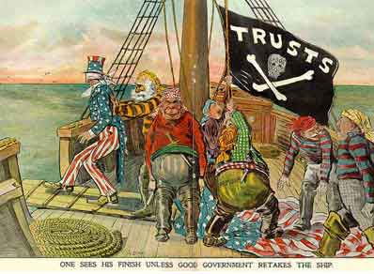

Document C
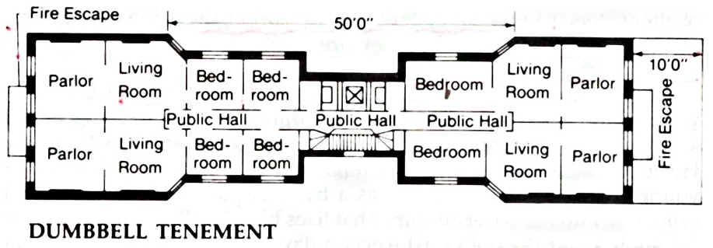

Document D: Cover of Puck Magazine, 1882
The answer is b Maishka is the best!!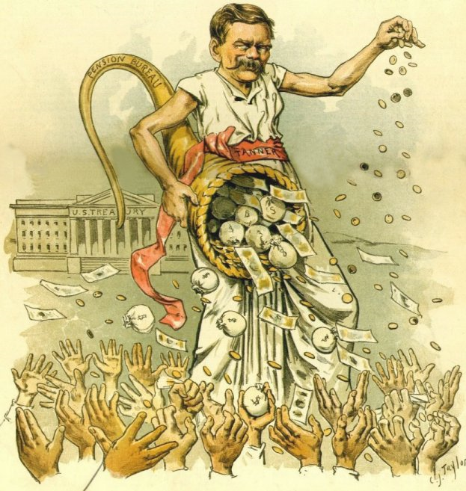

Document E: Excerpt from the Sherman Anti-Trust Act, 1890
Section 1:
"Every contract, combination in the form of trust or otherwise, or conspiracy, in restraint of trade or commerce among the several States, or with foreign nations, is declared to be illegal."
Section 2:
"Every person who shall monopolize, or attempt to monopolize, or combine or conspire with any other person or persons, to monopolize any part of the trade or commerce among the several States, or with foreign nations, shall be deemed guilty of a felony [. . . ]"

Document F: President Cleveland’s Letter to Illinois Governor Regarding the Pullman Strike, 1894

Sir: Federal troops were sent to Chicago in strict accordance with the Constitution and laws of the United States, upon the demand of the post-office department that obstruction of the mails should be removed, and upon the representations of the judicial officers of the United States that the process of the Federal courts could not be executed through ordinary means, and upon competent proof that conspiracies existed against commerce between the States. . . .

Document G: Political Cartoon from the 1896 Election
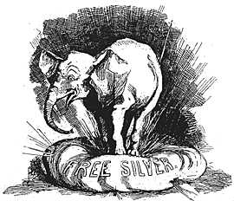

Document H: Excerpt from Supreme Court Decision, Plessy v. Ferguson, 1896
Laws permitting, and even requiring, their separation, in places where they are liable to be brought into contact, do not necessarily imply the inferiority of either race to the other, and have been generally, if not universally, recognized as within the competency of the state legislatures in the exercise of their police power. The most common instance of this is connected with the establishment of separate schools for white and colored children, which have been held to be a valid exercise of the legislative power even by courts of states where the political rights of the colored race have been longest and most earnestly enforced.

