**Reconstruction Document Analysis**

**Directions:** Attached to this handout is a DBQ that asks you the following question: **“**In the years immediately following the Civil War, were slaves really “free”?**”** The DBQ has 6 documents. Pick 6 of those 8 documents and complete the chart below (2 points per box).

|  |  |  |
| --- | --- | --- |
| **Doc** | **Does This Doc Suggest Slaves Were Really Free? (Yes or No?)** | **How Can You Tell?** |
|  |  |  |
|  |  |  |
|  |  |  |
|  |  |  |
|  |  |  |
|  |  |  |

Document A: The 13th Amendment (1865)

**Section 1.** Neither slavery nor involuntary servitude, except as a punishment for crime whereof the party shall have been duly convicted, shall exist within the United States, or any place subject to their jurisdiction.

**Section 2.** Congress shall have power to enforce this article by appropriate legislation.

Document B: 1865 South Carolina Law



Document C: 1865 South Carolina Law



Document D: 1865 Louisiana Law

Sec. 4. . . . Every negro is required to be in the regular service of some white person, or former owner, who shall be held responsible for the conduct of said negro.

Document E: 1865 Virginia Law

“1. Every white male citizen of the commonwealth, of the age of twenty-one years, who has been a resident of the state for two years, and of the county, city or town where he offers to vote, for twelve months preceding an election, who has paid all state taxes assessed to him for the preceding year, shall be qualified to vote from members of the general assembly, and all officers elective by the people . . . .”

Document F: Virginia School, 1866

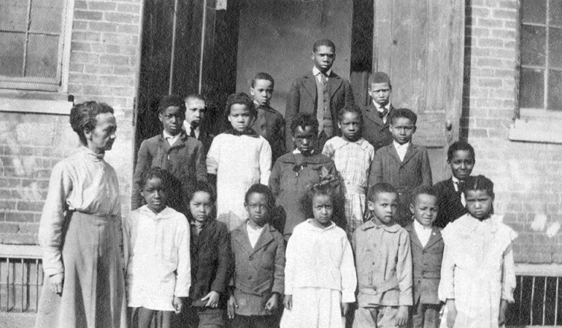

Document G: Political Cartoon (1868)

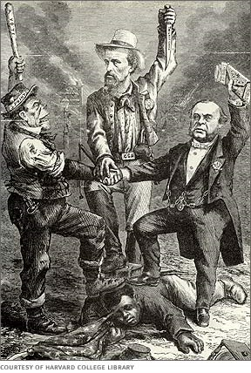

**Document H: 1886 Labor Contract**

Witnesseth-That Fenner Powell hath barganed and agreed with A. T. Mial to work as a cropper for the year 1886 on Mial's land on the land on the west Side of Poplar Creek and a point on the east Side of Said Creek and both South and North of the Mial road, leading to Raleigh. That the Fenner Powell agrees to work faithfully and dilligently with-out any unnecessary loss of time, to do all manner of work on the farm as may be directed by Mial, And to be respectful in manners and deportment to Mial.

And Mial agrees on his part to furnish mule and feed for the same and all plantation tools and Seed to plant the crop free of charge, and to give Powell One half of all crops raised and housed by Powell on the land except the cotton seed. Mial agrees to advance as provisions to Powell fifty pound of bacon and two sacks of meal per month and occationally Some flour to be paid out of Powell's part of the crop or from any other advance that may be made to Powell by Mial. As witness our hands and seals this the16th day of January A.D. 1886