Coming of Civil War Document Analysis
Directions: Attached to this handout is a DBQ that asks you the following question: “Was slavery in the South the principle cause of the Civil War?” Pick 6 of those 8 documents and complete the chart below.
Doc | Does This Doc Suggest Slavery in the South was the Main Cause of the Civil War? (Yes or No?) | How Can You Tell?

Source A: “Declaration of the National Anti-Slavery Convention, Part 1 of Annual Report of the American Anti-Slavery Society, 1834
We believe and affirm:
That every American citizen who retains a human being in involuntary bondage as his property is (according to scripture) a MAN STEALER….
That the slaves ought instantly to be set free….
That no compensation should be given to the planters emancipating their slaves… That if compensation is to be given at all, it should be given to the outraged and guiltless slaves and not those who have plundered and abused them.

Source B: “Declaration of the National Anti-Slavery Convention, Part 2 of Annual Report of the American Anti-Slavery Society, 1834
That we concede the Congress under the present national compact, has no right to interfere with any of the slave states, in relation this momentous subject (slavery). But we maintain that Congress has a right... to suppress the domestic slave trade between the several states, and to abolish slavery in those portions of our territory which the Constitution has placed under its [Congress’s] exclusive jurisdiction.

Source C: Amendment Proposed in House of Representatives, 1846
Provided, That, as an express and fundamental condition to the acquisition of any territory from the Republic of Mexico by the United States, by virtue of any treaty which may be negotiated between them, and to the use by the Executive of the moneys herein appropriated, neither slavery nor involuntary servitude shall ever exist in any part of said territory, except for crime, whereof the party shall first be duly convicted.

Source D: Copy of Harriet Beecher Stowe’s Uncle Tom’s Cabin, 1852
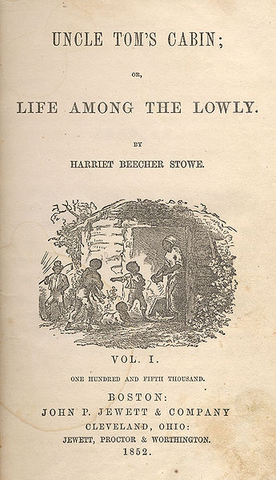

Document E: Map of the United States, 1854
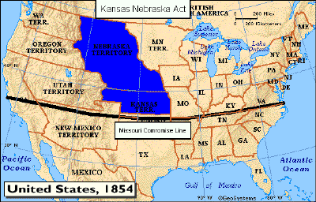

Document F: 1856 Illustration
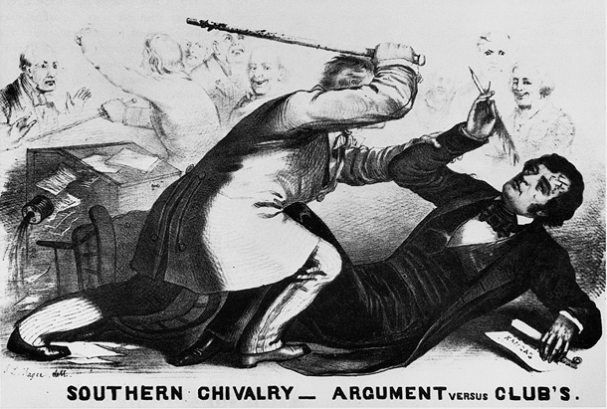

Document G: Speech by South Carolina Congressman, January 1860
"African slavery is the corner-stone of the industrial, social, and political fabric of the South; and whatever wars against it, wars against her very existence. Strike down the institution of African slavery and you reduce the South to depopulation and barbarism….The anti-slavery party contend that slavery is wrong in itself…. We of the South contend that slavery is right..."

Document H: Excerpt from Lincoln’s First Inaugural Address, March 1861
Apprehension seems to exist among the people of the Southern States, that by the accession of a Republican Administration, their property, and their peace, and personal security, are to be endangered. There has never been any reasonable cause for such apprehension. Indeed, the most ample evidence to the contrary has all the while existed, and been open to their inspection. It is found in nearly all the published speeches of him who now addresses you. I do but quote from one of those speeches when I declare that "I have no purpose, directly or indirectly, to interfere with the institution of slavery in the States where it exists. I believe I have no lawful right to do so, and I have no inclination to do so."

