Market and Transportation Revolution: Document Analysis
Directions: Attached to this handout is a set of documents related to the following question: Was the overall impact of the market and transportation revolutions positive or negative? Pick 6 of the 8 documents provided and complete the chart below.

Doc | Was the Overall Impact of the Revolutions Positive or Negative? (+ or --?) | How Can You Tell?

Document A: Transportation Costs in 1800 and 1850

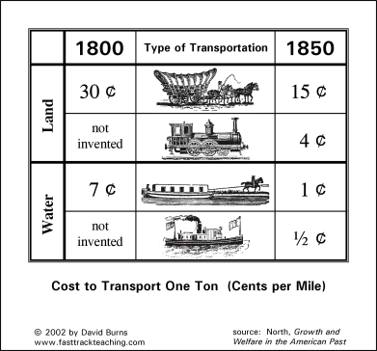

Document B: Cotton Production in the 19th Century
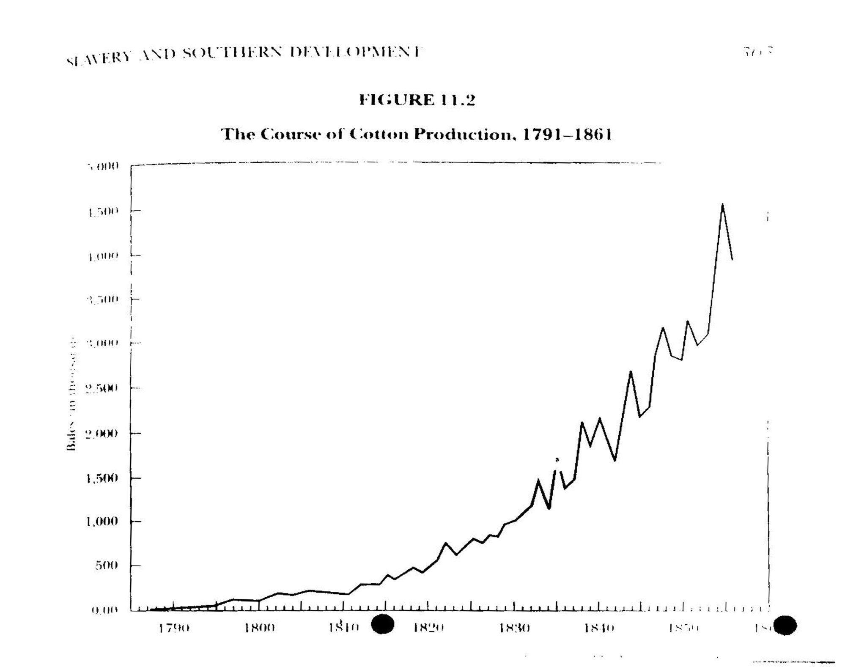

Document C: Age of Spinners at Samuel Slater’s Mill, 1840

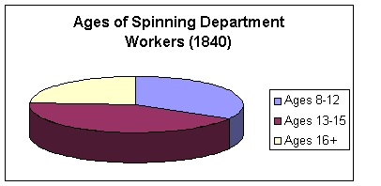

Document D: “Slaver” Wagons, Published in Voice of Industry, 1846

We were not aware, until within a few days, of the modus operandi of the factory powers in this village of forcing poor girls from their quiet homes to become their tools and, like the Southern slaves, to give up their life and liberty to the heartless tyrants and taskmasters.

Observing a singular-looking "long, low, black" wagon passing along the street, we made inquiries respecting it, and were informed that it was what we term a "slaver." She makes regular trips to the north of the state [Massachusetts], cruising around in Vermont and New Hampshire, with a "commander" whose heart must be as black as his craft, who is paid a dollar a head for all he brings to the market, and more in proportion to the distance-if they bring them from such a distance that they cannot easily get back.

This is done by "hoisting false colors," and representing to the girls that they can tend more machinery than is possible, and that the work is so very neat, and the wages such that they can dress in silks and spend half their time in reading. Now, is this true? Let those girls who have been thus deceived, answer….

Is there any humanity in this? Philanthropists may talk of [African] slavery, but it would be well first to endeavor to emancipate the slaves at home. Let us not stretch our ears to catch the sound of the lash on the flesh of the oppressed black while the oppressed in our very midst are crying out in thunder tones, and calling upon us for assistance.

Document E: The Demand for a 10 Hour Day, 1835
In the name of the Carpenters, Masons, and Stone Cutters [we] do respectfully represent--
That we are now engaged in a cause which is not only of vital importance to ourselves, our families, and our children, but is equally interesting and equally important to every mechanic in the United States and the whole world. We are contending for the recognition of the natural right to dispose of our own time in such quantities as we deem and believe to be most conducive to our own happiness and the welfare of all those engaged in manual labor.
The work in which we are now engaged is neither more nor less than a contest between money and labor. Capital, which can only be made productive by labor, is endeavoring to crush labor, the only source of all wealth.
We have been too long subjected to the odious, cruel, unjust, and tyrannical system which compels the operative mechanic to exhaust his physical and mental powers by excessive toil, until he has no desire to eat and sleep, and in many cases he has no power to do either from extreme debility. . . .
It is for the rights of humanity we contend. Our opposers resort to the most degrading obloquy to injure us. They tell us, "We shall spend all our hours of leisure in drunkenness and debauchery if the hours of labor are reduced." We hurl from us the base, ungenerous, ungrateful, detestable, cruel, malicious slander, with scorn and indignation. . . .

Document F: Political Cartoon in Ireland, 1840s

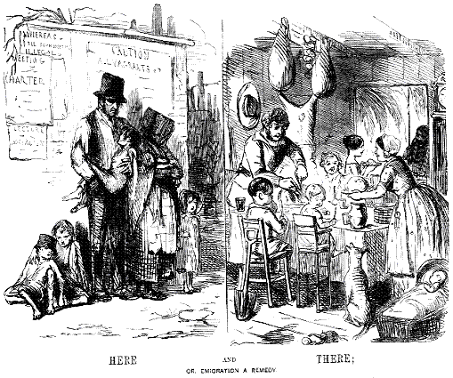

Document G: Flyer, 1845

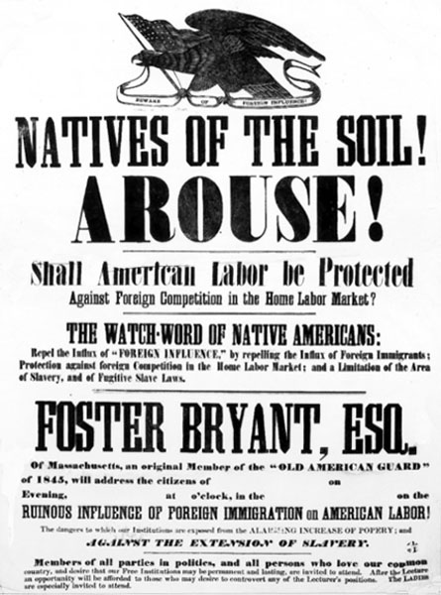

Document H: Travel Times in the 19th Century

