Slavery Document Analysis
Directions: Attached to this handout is a DBQ that asks you the following question: “How successful were anti-slavery organizations during the 1830s?” Pick 6 of those 8 documents and complete the chart below.
Doc | Does This Doc Suggest Anti-Slavery Organizations Were Successful? (Yes or No?) | How Can You Tell?

Source A: Excerpt from Garrison’s The Liberator (1831)
On this subject, I do not wish to think, or speak, or write, with moderation. No! no! Tell a man whose house is on fire, to give a moderate alarm; tell him to moderately rescue his wife from the hand of the ravisher; tell the mother to gradually extricate her babe from the fire into which it has fallen; -- but urge me not to use moderation in a cause like the present. I am in earnest -- I will not equivocate -- I will not excuse -- I will not retreat a single inch -- AND I WILL BE HEARD.

Source B: Petition to Congress (1835)

TO THE CONGRESS OF THE UNITED STATES
YOUR PETITIONERS, Ladies of the town of __________________, in the county of _______________, and state of ________________, beg leave to represent to your honorable body, that the people of the United States have vested in Congress, by the first Article of the Federal Constitution, “exclusive legislation, in all cases whatsoever,” over the District of Columbia.
Your Petitioners do not ask your honorable body to legislate for the abolition of slavery in the several states where it exists, but they do respectfully represent that duty to their country, to mankind, and to God, forbids Congress to exercise their power of “exclusive legislation,” to PERPETUATE SLAVERY AND THE SLAVE TRADE in the Capital of the American Republic. The acts of Congress hitherto passed for the government of said District in fact do this.
If these laws are ever to be repealed, and slavery and the slave trade in that District are thereby ever to cease, it must be by the action of Congress. Your Petitioners believe that no time can be more favorable for such action than the present. They therefore most respectfully but earnestly entreat your honorable body to pass without delay such laws, as to your wisdom may seem right and proper for the entire abolition of slavery and the slave trade in the District of Colombia.
Document C: 1836 Congressional Resolution
No petition, memorial, resolution, or other paper praying the abolition of slavery in the District of Columbia, or any State or Territory, or the slave trade between the States or TERRITORIES OF THE UNITED STATES, in which it now exists, shall be received by this House, or entertained in any way whatever. As a formal House rule rather than a resolution, the gag rule was now a permanent part of House procedure and did not have to be renewed by vote each session

Document D: Census Data on Slavery
Census  Year | # Slaves
1790 | 697,681
1800 | 893,602
1810 | 1,191,362
1820 | 1,538,022
1830 | 2,009,043
1840 | 2,487,355

Document E: 1833 Excerpt from Richard H. Colfax's Evidence Against the Views of the Abolitionists
His lips are thick, his jaws large and projecting,--his chin retreating,--his forehead low, flat and slanting, and (as a consequence of this latter character,) his eyeballs are very prominent,--apparently larger than those of white men;--all of these peculiarities at the same time contributing to reduce his facial angle almost to a level with that of the brute--Can any such man become great or elevated?--the history of the Africans will give a decisive answer.
Modern anatomists have fixed the average facial angle of the European at 80--negro 70,--ourang outang 58--all brutes below 70, the average angle of quadrupeds being about 20.
If then it is consistent with science, to believe that the mind will be great in proportion to the size and figure of the brain: it is equally reasonable to suppose, that the acknowledged meanness of the negroe's intellect, only coincides with the shape of his head; or in other words, that his want of capability to receife a complicated education renders it improper and impotitic, that he should be allowed the privileges of citizenship in an enlightened country!

Document F: Engraving of Elijah Lovejoy, 1837
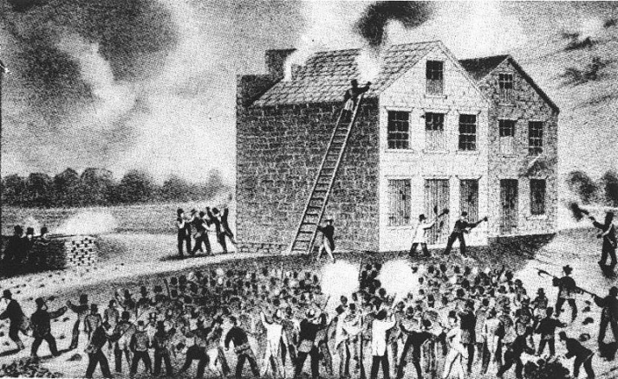
Document G: Map of the Underground Railroad
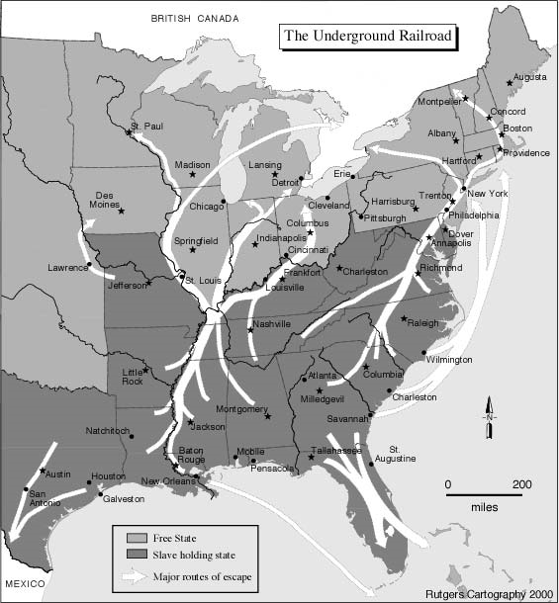

Document H: 1840 Presidential Election Results
Presidential Candidate | Party | Popular Vote % | Electoral Vote
Harrison | Whig | 53% | 234
Van Buren | Democrat | 47% | 60
Birney | Liberty | .3% | 0

