**Document Based Question – Progressive Movement**

**Historical Context:**

The late 1800’s and early 1900’s were times of great reform in America. Tired of the poor working conditions, overcrowding of cities, political corruption and abuses by industrialists, people known as Progressives took it upon themselves to create change. By using various forms of the media, combined with organized protests, petitions, and the power of the vote, the Progressives exposed these issues, and informed thousands of Americans of the conditions that existed. The result was a short-lived era of reform, in which social, political, and industrial conditions were targeted and improved.

**Main Question: Describe the social and political conditions that existed in America just prior to the Progressive Movement. Discuss how the Progressives informed their audiences of these conditions, and explain the extent to which they were successful in reforming several of the problems they addressed.**

**Your essay should be structured as follows:**

* **Introduction**
* **1st Body Paragraph: Social/Political Conditions prior to Progressivism**
* **2nd Body Paragraph: How Progressives informed audiences of conditions**
* **3rd Body Paragraph: Explain the extent to which these reforms were successful**
* **Conclusion**

**Directions:** The following documents illustrate conditions that existed before, during, and after the Progressive Movement. Examine each document carefully and then answer the question that follows it.

**Document 1**

Excerpt from *How the Other Half Lives* by Jacob Riis

"If we could see the air breathed by these poor creatures in their tenements," said a well-known physician, "it would show itself to be fouler than the mud of the gutters." Little improvement was apparent despite all that had been done. "The new tenements, that have been recently built, have been usually as badly planned as the old, with dark and unhealthy rooms, often over wet cellars, where extreme overcrowding is permitted," was the verdict of one authority.

1. **What problems does Jacob Riis see with life in city tenements?**

**Document 2**

Excerpt from President Woodrow Wilson’s First Inaugural Address, March 4, 1913

We see that in many things (our) life is very great…but…evil has come with the good…With riches has come inexcusable waste. We have squandered (wasted) a great part of what we might have used, and have not stopped to conserve the exceeding bounty of nature…We have been proud of our industrial achievements, but we have not … stopped thoughtfully enough to count the human costs…(Our) great Government we loved has too often been made use of for private and selfish purposes, and those who used it had forgotten the people.

At last a vision has been (shown to) us of our life as a whole. We see the bad with the good…With this vision we approach new affairs. Our duty is to cleanse, to reconsider, to restore, to correct the evil…to purify and humanize every process of our common life…

**1. Woodrow Wilson recognizes that "evil has come with the good." Identify three "evils" that Wilson discusses. (You do not need to identify the "good")**

1. **What does Wilson see as the new responsibility of Americans?**

**Document 3**

Excerpt from T*he Common Sense of the Milk Question* by John Spargo - a book advocating government control over the pasteurization and sale of milk in order to protect the health of babies and children (1908).

What I want to do is to place before the American public a calm and dispassionate statement of certain curable ills as a basis upon which to rest an earnest plea for action; to waken, if possible, all those dormant and neglected powers and impulses for good which need to be called into active cooperation in order that the evils may be remedied.

1. **What was John Spargo asking Americans to do after they read his book?**

**Document 4**

Child Labor Photograph from Lewis Hine c. 1908

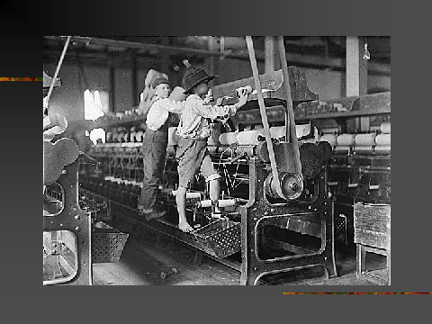

1. **Use the photograph to identify two dangers that children faced at work.**

**Document 5**

Chronology of Major Events

1883 Civil Service Act

1890 Jacob Riis publishes *How the Other Half Lives*

1904 Ida Tarbell Publishes *History of Standard Oil*

1906 Upton Sinclair publishes *The Jungle*

1906 Pure Food and Drug Act passes

1906 Meat Inspection Act passes

1908 President Roosevelt calls national conservation conference

1913 16th Amendment sets up federal income tax

1913 17th Amendment calls for direct election of U.S. senators

1916 Keating Owens Act limits child labor

1917 18th Amendment prohibits making or selling alcoholic drinks

1920 19th Amendment gives women the right to vote

**1. Identify four political reforms that were made during the Progressive Movement?**

**Document 6**

Excerpt from *The Jungle* by Upton Sinclair

"These rats were nuisances, and the packers would put poisoned bread out for them: they would die, and then rats, bread, and meat would go into the hoppers together. This is no fairy story and no joke…there were things that went into the sausage in comparison with which a poisoned rat was a tidbit."

1. **According to Upton Sinclair, where did the poisoned rats ultimately end up?**

**Document 7**

Rose Schneiderman was an advocate for Women’s Rights during the Progressive Era

" Women in the laundries stand for 13 and 14 hours in the terrible steam and heat with their hands in hot starch. Surely these women won’t lose any more of their beauty and charm by putting a ballot in the ballot box." Rose Schneiderman

**1. What did Rose Schneiderman say to people who considered voting unladylike?**

**Document 8**

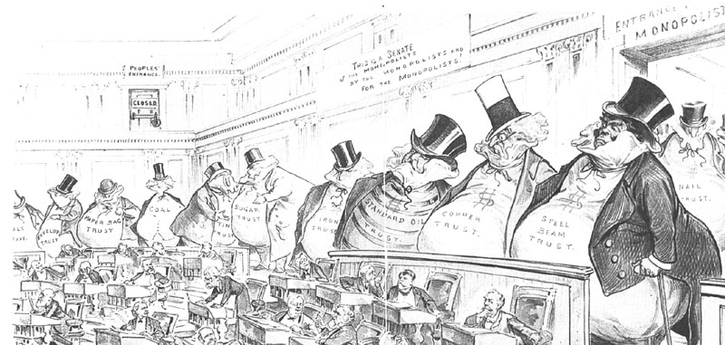

**1. According to the cartoon, whose interests was the Senate serving?**

**ONCE YOU HAVE COMPLETED ANSWERING THE QUESTIONS FOR EACH DOCUMENT; BEGIN YOUR DBQ ESSAY. BE SURE TO USE EACH DOCUMENT TO SUPPORT YOUR OPINIONS AND CITING SPECIFIC DETAILS AND/OR QUOTES FROM THE DOCUMENTS.**