Manifest Destiny Document Analysis
Directions: Attached to this handout is a set of documents related to the following question: Did Manifest Destiny and territorial expansion unite or divide the United States in the early 1800s? Pick 6 of the 8 documents provided and complete the chart below.

Doc | Did Manifest Destiny unite or divide the US? (Unite or Divide?) | How Can You Tell?

Document A: Map of the United States, 1820s

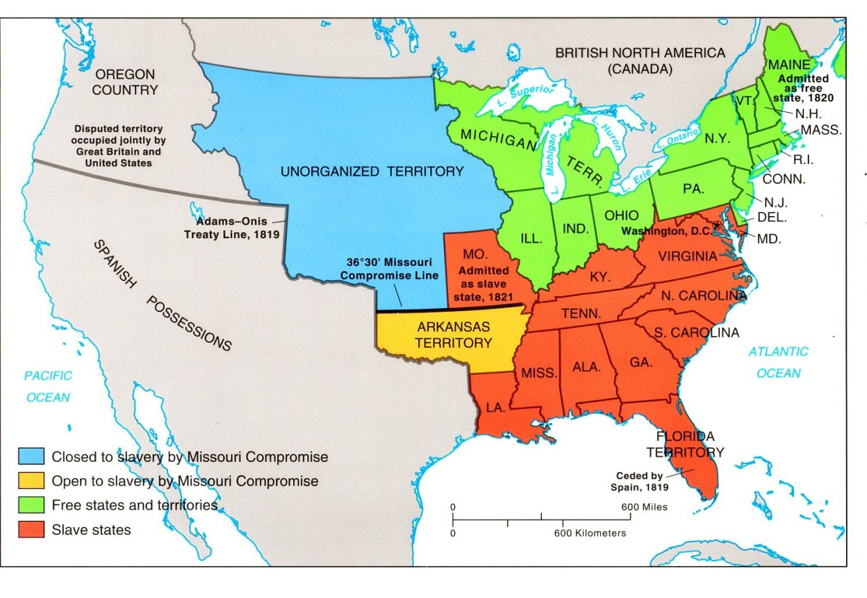

Document B: Vote on Indian Removal Act, 1830

 | For | Against
Senate | 28 | 19
House of Representatives | 102 | 97

Document C: American Progress, Painting, 1872

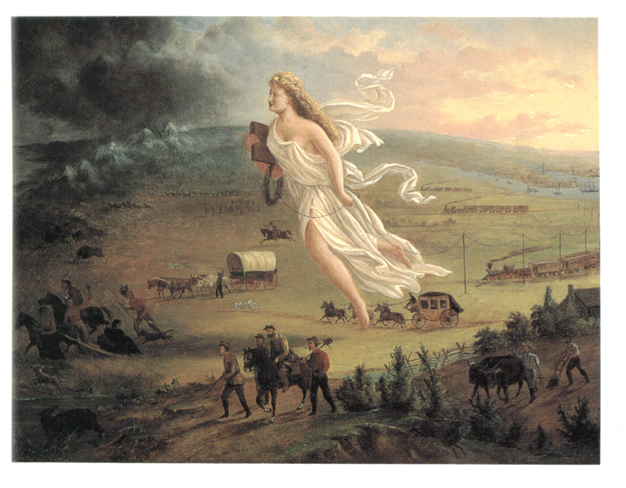

Document D: Senator Thomas Hart Benton, Speech in US Senate, 1844

After twenty-five years, the American population has begun to extend itself to the Oregon. Some hundreds went a few years ago; a thousand went last year; two thousand are now setting out from the frontier of Missouri; tens of thousands are meditating the adventure. I say to them all, Go on! The Government will follow you, and will give protection and land….

Let the emigrants go on, and carry their rifles. We want thirty thousand rifles in the valley of the Oregon; they will make all quiet there, in the event of a war with Great Britain for the domination of that country…. They will protect the American interests in all the vast region of the Rocky Mountains. Besides…. The settlers in Oregon will also recover and open for us the North American road to India!

Document E: John L. O’Sullivan, Democratic Review, 1845

Away, away with all these cobweb tissues of the rights of discovery, exploration, settlement….the American claim is by the right of our manifest destiny to overspread and possess the whole of the continent which Providence has given us for the development of the great experiment of liberty.

Document F: The Wilmot Proviso, 1846
Provided that, as an express and fundamental condition to the acquisition of any territory from the Republic of Mexico by the United States, by virtue of any treaty which may be negotiated between them, and to the use by the Executive of the moneys herein appropriated, neither slavery nor involuntary servitude shall ever exist in any part of said territory, except for crime, whereof the party shall first be duly convicted

Document G: Charles Sumner, Massachusetts Legislature, 1847

Resolved. That the present war with Mexico has its primary origin in the unconstitutional annexation to the United States of the foreign state of Texas while the same was still at war with Mexico; that it was unconstitutionally commenced by the order of the President, to General Taylor, to take military possession of territory in dispute between the United States and Mexico, and in the occupation of Mexico;

And that it is now waged ingloriously – by a powerful nation against a weak neighbor – unnecessarily, and without just cause, at immense cost of a portion of her territory, from which slavery has already been excluded, with the triple object of extending slavery, of strengthening “Slave Power”, and of obtaining the control of the Free States, under the Constitution of the United States.

Document H: Abraham Lincoln, Excerpts from Speech in House of Representatives, 1847

Resolved That the President of the United States be respectfully requested to inform this House -
1st. Whether the spot on which the blood of our citizens was shed, as in his messages declared, was or was not within the territory of Spain, at least after the treaty of 1819, until the Mexican revolution.
2d. Whether that spot is or is not within the territory which was wrested from Spain by the revolutionary Government of Mexico.
5th. Whether the people of that settlement, or a majority of them, or any of them, have ever submitted themselves to the government or laws of Texas or the United States, by consent or compulsion, either by accepting office, or voting at elections, or paying tax, or serving on juries, or having process served upon them, or in any other way.

