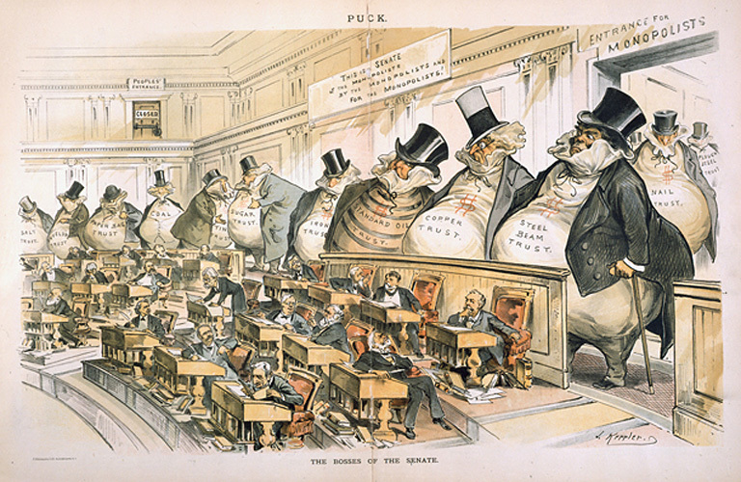
Joseph Keppler, “Bosses of the Senate” Puck (1889)
The magazine “Puck” published political satire during the last quarter of the 19th century. The cartoon above, like most of the images in Puck, reflects contemporary concerns and anxieties

Identify: Which figures in this cartoon are most prominent? What do they represent? What details explain what they represent?

Analyze: What is the relationship between the larger and smaller men in this picture? What does this tell you about the artist’s perception of business and government at the same time?

Evaluate: Satire is the use of humor, irony, ridicule, or exaggeration as a form of criticism. Does this image distort the relationship between big business and the US Government? Explain.

Andrew Carnegie, “The Gospel of Wealth” (1889)
By the end of 19th century, Andrew Carnegie (1835-1919) had built the Carnegie Steel Company into the largest steel manufacturer in the United States. His essay “The Gospel of Wealth” (originally entitled “Wealth”) appeared in the North American Review at the height of his cultural influence.
“There remains, then, only one mode of using great fortunes; but in this we have the true antidote for the temporary unequal distribution of wealth, the reconciliation of the rich and the poor--a reign of harmony--another ideal, differing, indeed, from that of the Communist in requiring only the further evolution of existing conditions, not the total overthrow of our civilization. It is founded upon the present most intense individualism, and the race is projected to put it in practice by degree whenever it pleases. Under its sway we shall have an ideal state, in which the surplus wealth of the few will become, in the best sense the property of the many, because administered for the common good, and this wealth, passing through the hands of the few, can be made a much more potent force for the elevation of our race than if it had been distributed in small sums to the people themselves. Even the poorest can be made to see this, and to agree that great sums gathered by some of their fellow-citizens and spent for public purposes, from which the masses reap the principal benefit, are more valuable to them than if scattered among them through the course of many years in trifling amounts.”

Identify: What does Carnegie mean when he says ‘public purposes” toward the end of this paragraph?

Analyze: How does Carnegie argue that wealth that is held by a few can ultimately help the masses?

Evaluate: Evaluate Carnegie’s argument that by identifying the potential flaws and strengths in his logic.
Explain your response.

