Mr. Hilbert Geography Final Study Guide

Part One: Mapping
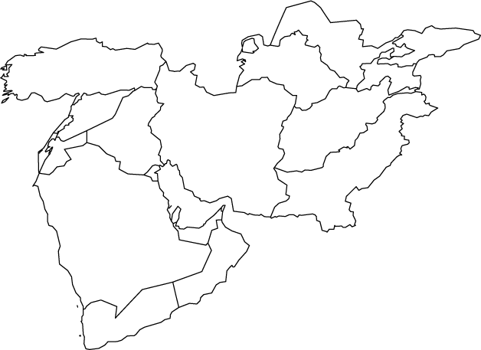
Know the names of all the countries listed above.
Part Two – Comparative Religion
Please know the basic information about these world religions
Name | Founder | Area Practiced | Name of God | Major Figures | Afterlife Concept
Islam
Christianity
Hinduism
Buddhism
Judaism
Sikhism
Confucianism
Part Three: Israel – Palestine Conflict
- Define and describe the significance of the following terms:
Balfour Declaration
Zionism
Six Day War
Israel
West Bank
Gaza Strip
Palestine
Refugee
Jerusalem

- Please be prepared to answer the following questions:
What is the basis of the conflict between Israel and Palestine?

What are the Holy Sites in Jerusalem that are sacred to all the groups there?

What SPECIFIC issues does the film “Promises” highlight about the struggle between Israelis and Palestinians living in Jerusalem? (Be ready to compare and contrast)

What impact did the recent move of the American Embassy to Jerusalem have on the region?

Part Four – Gulf War
- Define and describe the significance of the following terms:
Saddam Hussein
George H.W. Bush
Desert Storm
Iraq
Kuwait
- Please be prepared to answer the following questions:
Why did Iraq invade Kuwait?
How did the international community react to the invasion SPECIFICALLY?
What did the United States do to aid Kuwait?
What negatives came out of the Gulf War?

Part Five – Arab Spring
- Define and describe the significance of the following terms:
Arab Spring
Tunisia
President Ali
Egypt
Hosni Mubarak
Libya
Colonel Qaddafi
- Please be prepared to answer the following questions:
How did the Arab Spring start?
Be able to name three countries affected by the Arab Spring.
Be able to name three leaders removed during the Arab Spring
What were the goals of the Arab Spring?
What are Western governments worried about when these countries change governments?

Part Six – Syrian Civil War
- Define and describe the significance of the following terms:
President Assad
ISIS
Refugee Crisis
- Please be prepared to answer the following questions:
What is the basis of the Syrian Civil War?
How has the United States reacted to chemical strikes during the conflict?
How has the Syrian civil war become a humanitarian crisis?
What is the role of ISIS in the conflict and how have they impacted international affairs?

