FRENCH REVOLUTION PRIMARY SOURCES
LETTER FROM MARIE ANTIONETTE TO HER MOTHER, 1773
VERSAILLES, June 14.
MY DEAREST MOTHER,---
I absolutely blush for your kindness to me. The day before yesterday Mercy sent me your precious letter, and yesterday I received a second. That is indeed passing one's fête day happily. On Tuesday I had a fête which I shall never forget all my life. We made our entrance into Paris. As for honors, we received all that we could possibly imagine; but they, though very well in their way, were not what touched me most. What was really affecting was the tenderness and earnestness of the poor people, who, in spite of the taxes with which they are overwhelmed, were transported with joy at seeing us. When we went to walk in the Tuileries, there was so vast a crowd that we were three-quarters of an hour without being able to move either forward or backward. The dauphin and I gave repeated orders to the Guards not to beat any one, which had a very good effect. Such excellent order was kept the whole day that, in spite of the enormous crowd which followed us everywhere, not a person was hurt. When we returned from our walk we went up to an open terrace and stayed there half an hour. I cannot describe to you, my dear mamma, the transports of joy and affection which every one exhibited towards us. Before we withdrew we kissed our hands to the people, which gave them great pleasure. What a happy thing it is for persons in our rank to gain the love of a whole nation so cheaply. Yet there is nothing so precious; I felt it thoroughly, and shall never forget it.
Another circumstance, which gave great pleasure on that glorious day, was the behavior of the dauphin. He made admirable replies to every address, and remarked everything that was done in his honor, and especially the earnestness and delight of the people, to whom he showed great kindness.

What is the mood of Marie Antionette in the letter? What statements or phrases back up your assessment?

What is the mood of the French people towards Marie Antionette? What statements or phrases back up your assessment?

If you were to predict how the reign of Louis XVI and Marie Antionette would end up just based on this letter, what would it be like?

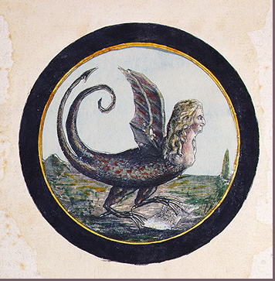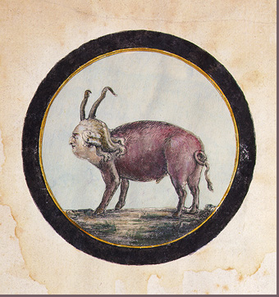
"Marie Antoinette as a Serpent" "Louis as Pig"
Well, things have changed. Two decades later the King and Queen are being portrayed as animals in a demeaning way.

What is the artist implying by drawing Marie Antoinette as a serpent? What does the serpent symbolize in our culture?

What is the artist implying by drawing Louis XVI as a pig? What does the pig symbolize in our culture?

How has the opinion of the royals changed from 1773-1792 from the two documents?

