Fairy Tale Rewrite Instructions
Rewrite the Fairy Tale
Goal: To retell the story / fairy tale / fable as if it takes place in the country you researched. You must be sure that the main idea or message of the story remains intact.

In your rewrite, explicitly identify your changes through color code. The example below shows appropriate usage of the highlighter feature. Each story will have at least one example of each Theme (the 5 themes of Geography). Your story must have at least one example of each theme, but there should be multiple examples within the story of identified themes that must be changed to be appropriate for the new location of the story.
When I grade the rewrite, I will be looking for examples of each theme identified by color, and the new word you use to replace it.

HOW TO:Place a copy of the story in a table (2 columns). Highlight the words you will need to replace with the color of the theme they represent (see example below). In the right column, list the replacement word you will use in your final rewrite. (i.e. in the example below, the name Cinderella (Human Characteristic of PLACE) will be replaced with Anastasia ( a name appropriate for Russia, the new location of the story)

Cinderella
Place, Location Region Human Environmental Interaction Movement

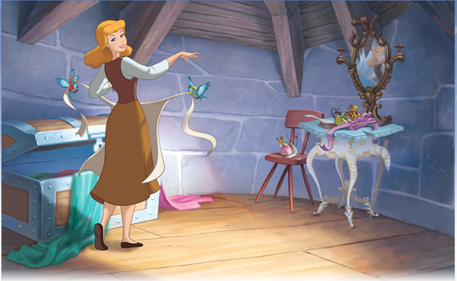

Which of the items in the scene need to be changed based on her new location?
*Wood floor, brick walls, furniture style, her clothing, the birds, metal on the storage box, the mice, and anything else that is based on her being in England in a forest.
(see example on next page)

Example -  Once upon a time, there was a kind girl named Cinderella.  All of the animals loved her, especially two mice named Gus and Jaq. They'd do anything for the girl they called Cinderelly. . Cinderella spent her days cleaning the wooden floors and stone fireplace, sewing the ragged clothes of her step-sisters and tilling the fields outside the house. | (Anastasia)  (two gophers)  (Dimitri and Ivan)  (Ana)  (sweeping the dirt floors)  (brick furnace)  (Making the cloth babushka’s )  (planting the turnips in the garden)

Together, read through a story, deleting any details that do not agree with the information you found about the country you researched. Replace those details with things that are consistent with the culture of the country researched.
For example, if in the country researched the people live in tents and in the fairy tale there is a castle, this must be changed. The castle might become a large tent.

Select more items of information from your research to include in the story. Work the information in creatively throughout the tale. You may change as much as you want, as long as it does not change the main idea of the story. One thing to consider is the name of the main character, should it be changed to a name that seems more appropriate for the country researched?

Once all the changes have been made and agreed upon, type a final draft of the story. Your typed story should be no less that two pages long. See if you can find a “Fairy Tale looking” font to use in your re-write.

.

