A – Apollo Program
http://www.nasm.si.edu/exhibitions/gal114/gal114.htm

Using the website, explore the links and do some research to complete the following. Once at the main page, read the information there, after you have finished reading the introduction, click on the “enter now” link. Your final copy of the page should be presented in paragraph form. This website should be cited in your bibliography. Remember to include an illustration on your final copy of your page. Your final product should completely answer every aspect of the questions.

- There are three types of rockets, what are their purposes?

- What was the first military rocket? Who developed it? How did the United States take advantage of this weapon?

- What was the first man-made satellite? Who put it into orbit?

- Who is Ivan Ivanovich? How did he prepare for future space flights?

- Who is considered the first man in space?

- What was America’s response to the Soviet Union’s space success?

- Identify all of the first Russian and American people in space.

- Describe the Mishin diaries. What is he writing about?

- What was the purpose of reconnaissance satellites?

- Who owns space? Why is this an important question in the space race?

- How many attempts at launching a satellite did it take before America was successful?

- What was America’s first successful spy satellite?

- How do reconnaissance satellites prove or disprove the missile gap?

- What was Skylab? How did it change American public opinion?

- What is significant about the Apollo-Soyuz Test Project? Why do most historians consider it the end of the space race?

- How is a space shuttle different from other space going vehicles?

- Who first had plans to send people to Mars? When did they hope to accomplish this?

- How is the space race reflective of the wider Cold War?
B - Berlin
Using The First Major Event of the Cold War: The Berlin Airlift, as well as other resources available, including class notes, handouts, and textbook, complete the following. Your final copy of the page should be presented in paragraph form. Remember to include an illustration on your final copy of your page. Your final product should completely answer every aspect of the questions.

- Using the maps, color-code the different occupation zones so that they are clearly identifiable (Red for the Soviet Zone, Blue for the U.S. zone, Green for the British zone, and Yellow for the French zone). This will be your illustration for this page.

- What were the primary causes of the Berlin Airlift?

- Why do you think the U.S. military acted so quickly to help the people of Berlin?

- What were the major effects of the Berlin Airlift?
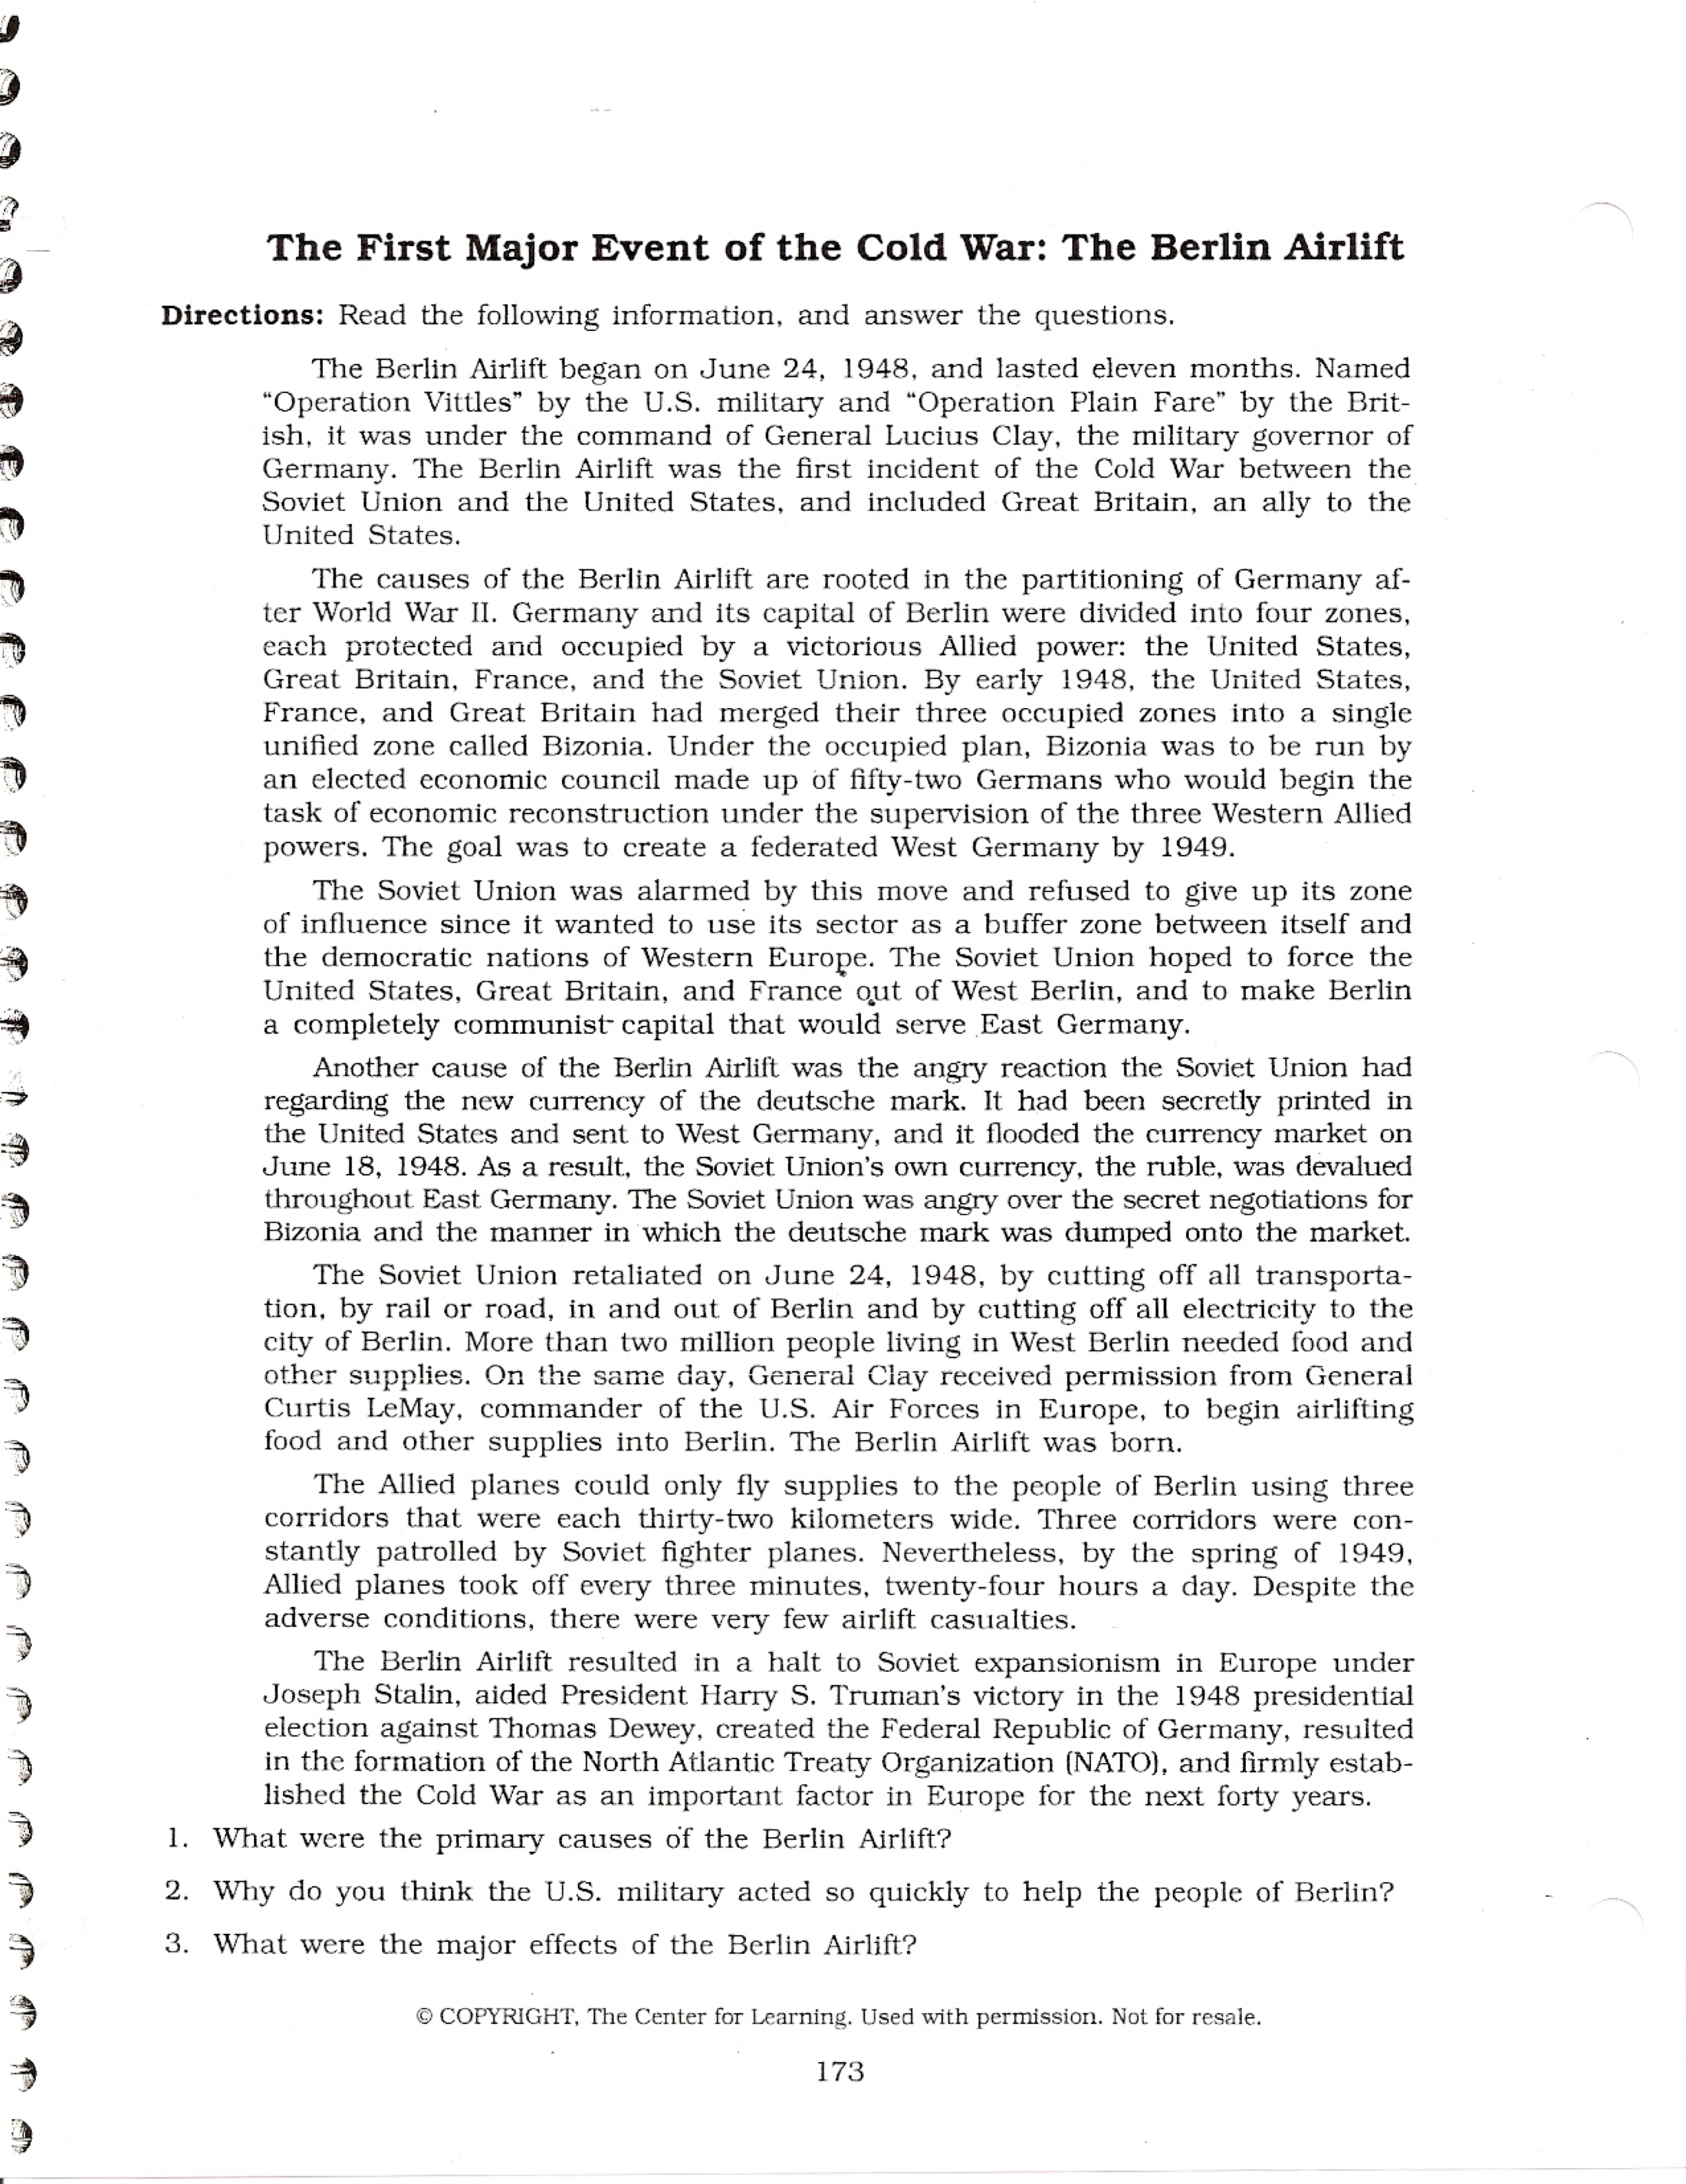
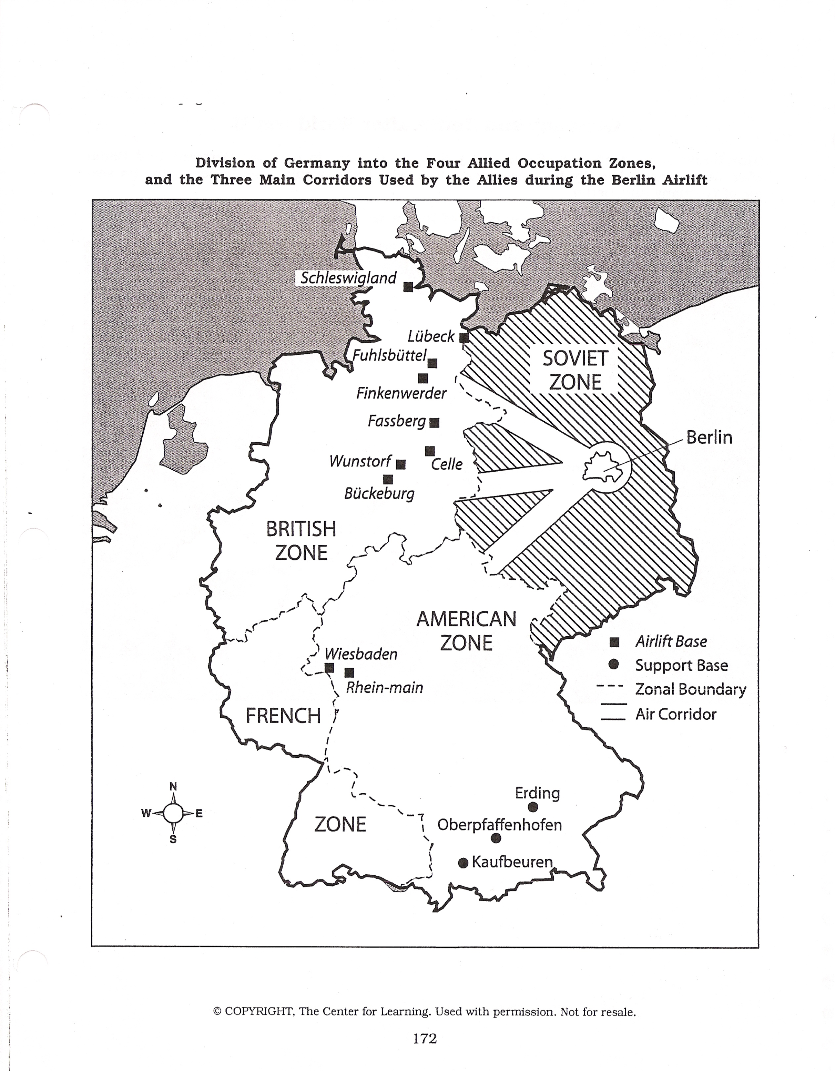
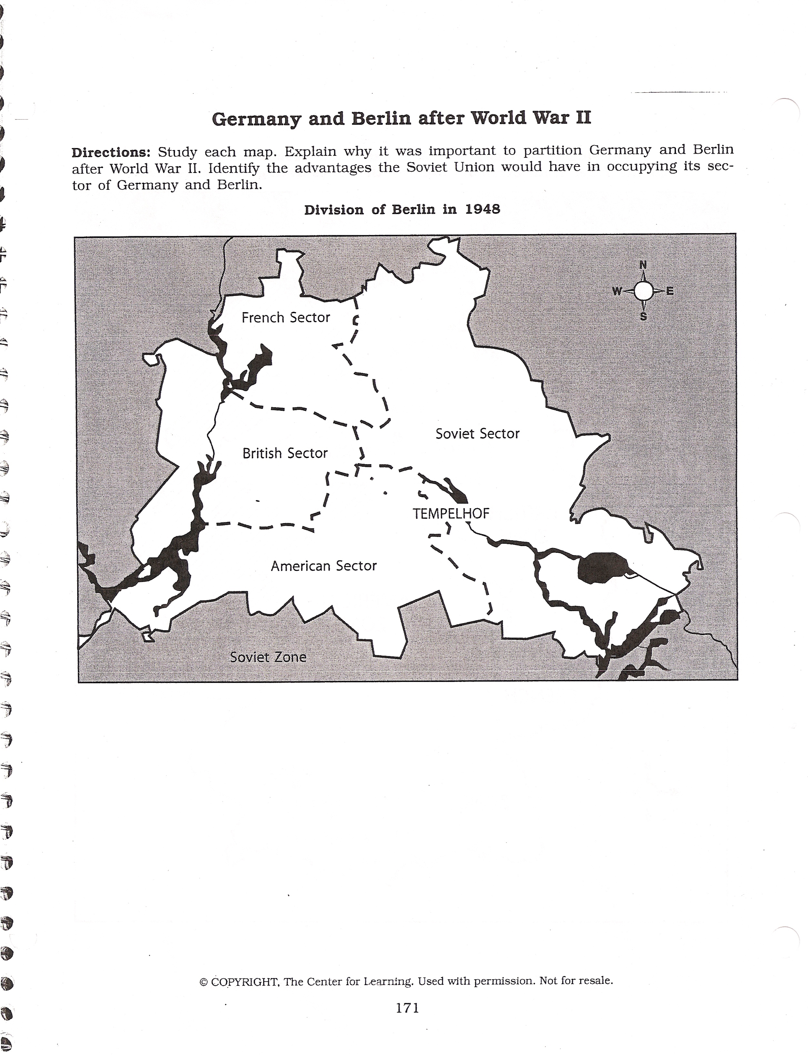
C – Cuban Missile Crisis
Using the resources available, including class notes, handouts, and textbook, complete the following. Your final copy of the page should be presented in paragraph form. Remember to include an illustration on your final copy of your page. Your final product should completely answer every aspect of the questions.

- Why is the United States upset when Cuba “goes Communist?”

- Why did the Soviet Union wish to place nuclear missiles on the island of Cuba?

- How does Khrushchev view the United States? Is he willing to back down to American power?

- Does Khrushchev plan on helping Cuba? How does he intend to help them? What textual evidence supports this?

- Is Khrushchev trying to intimidate the United States? What is he using as intimidation?

Modern History Sourcebook: Nikita Khrushchev: Speech to the RFSR Teacher's Congress - on Cuba, Moscow, July 9, 1960

A few days ago the Governor of New York State, Rockefeller, openly called for struggle against the government of Cuba and the Cuban people. He advised that a course directed against Cuba should be taken and that the regime chosen by the people should be stifled through economic blockade.
Rockefeller's pronouncements are an obvious example of the aggressive actions of American politicians who arc not accustomed to taking the will of the people into account.
But the time when the United States diktat prevailed is over. The Soviet Union is raising its voice on behalf of, and is offering help to, the people of Cuba who are fighting for their independence. The times are not now the same as they were when only one working class-the working people of former tsarist Russia-was raising the banner of struggle, when not only economic blockade but also armed intervention was organized against us.
Times are quite different now. Over 1,000 million people live in states where the working class and the working people have triumphed and where the glorious banner of Marxism-Leninism is flying. The world socialist camp is now stronger than ever before. The peoples of the socialist countries will help their Cuban brothers to uphold their independence with the object of frustrating the economic blockade the United States of America has just declared against Cuba.
And not only we, the working people of the socialist camp, but the peoples of all countries must be vigilant against the intrigues of the American imperialists.
It is clear to everybody that economic blockade by the American monopolists can be a prelude to intervention against Cuba. Therefore we must speak up in defense of Cuba and give warning that the imperialists can no longer rob and divide the world as they please, each choosing any piece for himself, as they used to do in the past. Today the peoples of the colonial and dependent countries rebel and fight successfully to rid themselves of the shameful colonial yoke and of enslavement by the United States imperialists. For our part, we shall do everything to support Cuba and her courageous people in their struggle for the freedom and national independence which they have Won under the leadership of their national leader Fidel Castro.
The socialist states and all peoples who stand for peace will support the Cuban people in their just struggle and no one will succeed in enslaving the Cubans.
It should be borne in mind that the United States is now not at such an inaccessible distance from the Soviet Union as formerly. Figuratively speaking, if need be, Soviet artillerymen can support the Cuban people with their rocket fire, should the aggressive forces in the Pentagon dare to start intervention against Cuba. And the Pentagon would be Well advised not to forget that, as has been shown by the latest tests, we have rockets which land accurately in a predetermined square target 13,000 kilometers [about 8,000 miles] away. This, if you wish, is a warning to those Who might like to solve international problems by force and riot by reason.
I have a note here that has been handed to me which say's that I have apparently, made a slip. The rocket covered not 30,000 kilometers, but 13,000. Well, that is enough! Of course, 30,000 kilometers was a slip and I want to correct the figure, for my speech is being broadcast. Let the Pentagon record that it was a slip; so far we have shot over a distance of 13,000 kilometers, and there is no need to shoot over 30,000. Am I correct, Comrade Malinovsky? Rodion Yakolcvich Malinovsky has confirmed this.

Source:
From Soviet News, No. 4304 (July 11, 1960), pp. 28-29.

D – Dubcek/Soviet Separatists
Using the resources available, including class notes, handouts, and textbook, complete the following. Your final copy of the page should be presented in paragraph form. Remember to include an illustration on your final copy of your page. Your final product should completely answer every aspect of the questions.

- Who was Alexander Dubcek?

- What was the Prague Spring?

- What were the four reasons for the collapse of the Soviet Union? Describe each one in detail, using specific examples whenever possible.

A)

B)

C)

D)

- After the collapse of the Soviet Union, what new nations were created?

- What do you think was the most important reason for the collapse of the Soviet Union?
E – Espionage
Using the resources available, including class notes, handouts, and textbook, complete the following. Your final copy of the page should be presented in paragraph form. Remember to include an illustration on your final copy of your page. Your final product should completely answer every aspect of the questions.

- Design your own spy gadget. Give a visual description of your gadget – Draw It! (This is your illustration).

- What is the purpose of your gadget?

- How does it work?

- Why would it be important for a spy to have?
F – Federal Republic of Germany & German Democratic Republic

Using the resources available, including class notes, handouts, and textbook, complete the following. Your final copy of the page should be presented in paragraph form. Remember to include an illustration on your final copy of your page. Your final product should completely answer every aspect of the questions.

- Compare the governments of West Germany and East Germany
  - Who was the leader?

  - Was there a Legislature?

- Contrast the living conditions of West Germany and East Germany
  - What kinds of houses?

  - What kind of wages?

- How long was Germany divided?

- When did Germany re-unite?

- What led to the reunification of Germany?
G – Global Changes/End of Colonialism
Use information gained from the film Guns, Germs, and Steel. This will also require some additional research outside of class. This may include your textbook, encyclopedias, the Internet (remember to avoid wikipedia). Your final copy of the page should be presented in paragraph form. Remember to include an illustration on your final copy of your page. Your final product should completely answer every aspect of the questions.

- What allowed the Western European powers to colonize large areas of the world?

- What would the people who are colonized need in order to break free from European Rule?

- How did the Cold War allow colonies to gain independence?

For this question create a chart that addresses each of the sub-questions
- Find 5 nations today who are former colonies of a “Western” power:
  - What is the county’s name now?
  - Who colonized them?
  - What was their colonial name?
  - When did they gain their independence?
  - Was it a violent or peaceful independence process?
H – Hot Spots
Using the resources available, including class notes, handouts, and textbook, complete the following. Your final copy of the page should be presented in paragraph form. Remember to include an illustration on your final copy of your page. Your final product should completely answer every aspect of the questions.

- What common theme do all of the people/events from the video “We didn’t Start the Fire” have in common?

- Identify three (3) “hot spots” during the Cold War
    - Explain who was involved in the confrontation
    - When did it occur?
    - What was the conflict about?
    - Did it end? How?

1a | 2a | 3a
1b | 2b | 3b
1c | 2c | 3c
1d | 2d | 3d

- Billy Joel wrote the song “We didn’t Start the Fire” in 1989. What people/events were missing from the song?

- Write another verse for the song that incorporates these additional events

I – Israeli-Arab Conflict
Using the resources available, including class notes, handouts, and textbook, complete the following. Your final copy of the page should be presented in paragraph form. Remember to include an illustration on your final copy of your page. Your final product should completely answer every aspect of the questions.

- What are the roots of the Israeli-Arab conflict?

- When was the state of Israel created?

- How was the state of Israel created?

- What was the overall Arab reaction to the creation of Israel?

- What were the major conflicts fought by Israel over the past fifty years?

- What is the situation in Israel right now?

J – John Paul II/Holy Land
Using the resources available, including class notes, handouts, and textbook, complete the following. Your final copy of the page should be presented in paragraph form. Remember to include an illustration on your final copy of your page. Your final product should completely answer every aspect of the questions.

- Who was John Paul II?

- What was John Paul II’s role in the Cold War?

- What did John Paul II do for the major world religions?

- What are some major sites of importance to Judaism? Christianity? Islam?

- How has religion affected the Middle East? Provide a detailed answer.

- Briefly Compare Judaism, Christianity, and Islam. (This Venn Diagram counts as your illustration.)
Comparison of Statistics and Basics
 | Judaism | Christianity | Islam
adherents called | Jews | Christians | Muslims
current adherents | 14 million | 2 billion | 1.3 billion
current size rank | 12th largest | largest | 2nd largest
major concentration | Israel, Europe, USA | Europe, North and South America, rapid growth in Africa | Middle East, Southeast Asia
sacred text | Bible | Bible (Jewish Bible + New Testament) | Qur'an (Koran)
other written authority | Talmud, Midrash, Responsa | church fathers, church councils, papal decrees (Catholic only) | Hadith
religious law | Halakhah | Canon Law | Sharia
clergy | rabbis | priests, ministers, pastors, bishops | imams
house of worship | synagogue | church, chapel, cathedral | mosque
main day of worship | Saturday | Sunday | Friday
church and state | separate | separate | integrated

Comparison of Origins and History
 | Judaism | Christianity | Islam
date founded | unknown | c. 33 CE | 622 CE
place founded | Palestine | Palestine | Saudi Arabia
founder | Moses or Abraham | Jesus | Muhammad
original language(s) | Hebrew | Aramaic, Greek | Arabic
early expansion | little expansion; mostly confined to Palestine | within 60 years, churches in major cities in Palestine, Turkey, Greece and Rome entire Roman Empire by end of 4th cent. | within 12 years, entire Arabian peninsula; within 100 years, Muslim world stretched from the Atlantic to China
major splits | Reform/Orthodox, 1800s CE | Catholic/Orthodox, 1054 CE; Catholic/Protestant, 1500s CE | Shia/Sunni, c. 650 CE

Comparison of Religious Beliefs
 | Judaism | Christianity | Islam
type of theism | strict monotheism | Trinitarian monotheism | strict monotheism
ultimate reality | one God | one God | one God
names of God | Yahweh, Elohim | Yahweh, the Holy Trinity | Allah (Arabic for God)
other spiritual beings | angels and demons | angels and demons | angels, demons, jinn
revered humans | prophets | saints, church fathers | prophets, imams (especially in Shia)
identity of Jesus | false prophet | Son of God, God incarnate, savior of the world | true prophet of God, whose message has been corrupted
birth of Jesus | normal birth | virgin birth | virgin birth
death of Jesus | death by crucifixion | death by crucifixion | did not die, but ascended into heaven during crucifixion
resurrection of Jesus | denied | affirmed | denied
second coming of Jesus | denied | affirmed | affirmed
divine revelation | through Prophets, recorded in Bible | through Prophets and Jesus (as God Himself), recorded in Bible | through Muhammad, recorded in Qur'an
view of sacred text | views vary | inspired, some believe inerrant in original languages | inspired, literal word of God, inerrant in original languages
human nature | two equal impulses, one good and one bad | "original sin" inherited from Adam - tendency towards evil | equal ability to do good or evil
means of salvation | belief in God, good deeds | correct belief, faith, good deeds, sacraments (some Protestants emphasize faith alone) | correct belief, good deeds, Five Pillars; faith, prayer, concern for the needy, fasting, and the pilgrimage to Makkah
God's role in salvation | divine revelation and forgiveness | predestination, various forms of grace | predestination
good afterlife | views vary: either heaven or no afterlife | eternal heaven | eternal paradise
bad afterlife | views vary: either eternal Gehenna, reincarnation, or no afterlife | eternal hell, temporary purgatory (Catholicism) | eternal hell
view of fellow Abrahamic religions | Islam and Christianity are false interpretations and extensions of Judaism. | Judaism is a true religion, but with incomplete revelation. Islam is a false religion. | Jews and Christians are respected as "People of the Book," but they have wrong beliefs and only partial revelation.
Source: http://www.religionfacts.com/islam/comparison_charts/islam_judaism_christianity.htm

K – Korean War
Using the resources available, including class notes, handouts, and textbook, complete the following. Your final copy of the page should be presented in paragraph form. Remember to include an illustration on your final copy of your page. Your final product should completely answer every aspect of the questions.

- How does the Korean War reflect the wider Cold War?

- What is a proxy war?

- “Containment had worked.” Assess the validity of this statement.

- What is significant about the U.S. dismissing (firing) General MacArthur (a celebrated World War II hero)?

L – Little Red Book
Using the resources available, including class notes, the Quotations from Chairman Mao Tse-Tung handout, and textbook, complete the following. Your final copy of the page should be presented in paragraph form. Remember to include an illustration on your final copy of your page. Your final product should completely answer every aspect of the questions.

- What effect did the Great Leap Forward and the Cultural Revolution have on the Chinese people? The Chinese Government? What was Mao-Tse-Tung’s role in these two programs?

- Choose four of the seven quotes from Quotations from Chairman Mao Tse-Tung. For each quote:
  - Summarize its meaning. What is Mao saying?

  - What effect/application does this quote have on society?

Quotations from Chairman Mao Tse-Tung

The Communist Party
“A well-disciplined Party armed with the theory of Marxism-Leninism, using the method of self-criticism and linked with the masses of the people; an army under the leadership of such a party; a united front of revolutionary classes and all revolutionary groups under the leadership of such a Party – these are the three main weapons with which we have defeated the enemy.”

Classes and Class Struggle
“Classes struggle, some classes triumph, others are eliminated. Such is history, such is the history of civilization for thousands of years. To interpret history from this viewpoint is historical materialism; standing in opposition to this viewpoint is historical idealism.”

Socialism and Communism
“Socialist revolution aims at liberating the productive forces. The change-over from individual to socialist, collective ownership in agriculture and handicrafts and from capitalist to socialist ownership in private industry and commerce is bound to bring about a tremendous liberation of the productive forces. Thus the social conditions are being created for a tremendous expansion of industrial and agricultural production.”

War and Peace
“War is the highest form of struggle for resolving contradictions, when they have developed to a certain stage, between classes, nations, states, or political groups, and it has existed ever since the emergence of private property and of classes.”

The Mass Line
“We should go to the masses and learn from them, synthesize their experience into better, articulated principles and methods, then do propaganda among the masses, and call upon them to put these principles and methods into practice so as to solve their problems and help them achieve liberation and happiness.”

Revolutionary Heroism
“We the Chinese nation have the spirit to fight the enemy to the last drop of our blood, the determination to recover our lost territory by our own efforts, and the ability to stand on our own feet in the family of nations.”

Ideological Self-cultivation
“There are not a few people who are irresponsible in their work, preferring the light to the heavy, shoving the heavy load onto others and choosing the easy one for themselves. At every turn they think only of themselves before others. When they make some small contribution, they swell with pride and brag about it for fear that others will not know. They feel no warmth towards comrades and the people but are cold, indifferent and apathetic. In fact such people are not Communists, or at least cannot be counted as true Communists.”
M – Marshall Plan/Truman Doctrine
Using The Truman Doctrine and The Marshall Plan as well as other resources available, including class notes, and textbook, complete the following. Your final copy of the page should be presented in paragraph form. Remember to include an illustration on your final copy of your page. Your final product should completely answer every aspect of the questions.

- What is the domino theory?

- What is Truman asking for?

- What are the first and second "ways of life" that Truman refers to?

- According to Marshall, what is the major problem facing Europe?

- What is Marshall’s plan?

- Who gets to determine how Marshall’s plan will be implemented?

- Why does the US view the Marshall Plan as a vital part of the Truman Doctrine?

- From a Soviet perspective what are your reactions to the Truman Doctrine and the Marshall Plan?
N – Nuclear Arms
Using class notes and other resources available, including handouts, and textbook, complete the following. Your final copy of the page should be presented in paragraph form. Remember to include an illustration on your final copy of your page. Your final product should completely answer every aspect of the questions.

- What role did nuclear arms play in the Cold War? Explain the importance of nuclear arms to the development of the Cold War.

- How did the idea of Mutually Assured Destruction influence the policy of both the United States and the Soviet Union?

- In your judgment, what lead to the period of détente during the 1970s?

O – Organizations/NATO
Using the resources available, including class notes, handouts, and textbook, complete the following. For your final copy create a graphic organizer, which incorporates all of the information gathered below. Remember to include an illustration on your final copy of your page. Your final product should include all of the information that you gathered below.

For each organization:
Full name, Purpose, Member States
- NATO

- SEATO

- OAS

- CENTO

- EC

P – Presidents of the U.S.
Using the resources available, including class notes, handouts, and textbook, complete the following. Remember to include an illustration on your final copy of your page. Your final product should completely answer every aspect of the questions.

For each president listed below write four to five bullet points detailing how that president affected the Cold War. Your final copy may be presented as a list/chart. Be sure to include the name and date of each president. Remember to include any outside sources you may use in your bibliography.

Each bullet point should reflect:
  - What is the event?
  - Where did this occur?
  - When did this occur?
  - Effect on international relations/U.S. foreign policy/Cold War relations?

Harry Truman (1945-1953)

Dwight Eisenhower (1953-1961)

John F. Kennedy (1961-1963)

Lyndon Johnson (1963-1969)

Richard Nixon (1969-1974)

Gerald Ford (1974-1977)

Jimmy Carter (1977-1981)

Ronald Reagan (1981-1989)

Q – Questioning/McCarthyism
Using the resources available, including class notes, handouts, and textbook, complete the following. Your final copy of the page should be presented in paragraph form. Remember to include an illustration on your final copy of your page. Your final product should completely answer every aspect of the questions.

- Who is Joseph McCarthy and what role did he play in the American anti-communist movement?

- After founding out the Soviets had the bomb, Americans became increasingly sensitive about threats to internal security. How did this feeling pave the way for McCarthy’s Red Scare?

- What originally prompted Senator McCarthy to make his infamous speech claiming he held in his hands the names of 205 known communists in the State Department?

- Did the Red Scare violate constitutional rights of American citizens? Explain your answer.

- What influence did the media have on the Red Scare?

Introduction/Background

Whatever the deeper causes of the Second Red Scare, few doubt that Senator Joseph R. McCarthy did more than any other individual to turn the concern about domestic disloyalty and security into a form of national hysteria. His name still stirs violent emotions in those who lived through that turbulent period. The words McCarthyism and McCarthyite have become a part of our language.
"A man without moral perceptions," in the words of one recent biographer, "one who will break all the rules because for him there are none," McCarthy had floundered through four years in the Senate and was desperately searching for an issue that would increase his visibility and would aid his plans for reelection when he appeared before the Ohio County Women's Republican Club in Wheeling, West Virginia, on February 9, 1950. Following the outline of speeches by other Republican anticommunists, McCarthy charged that the United States had lost ground in the world not as a result of foreign aggression, but "because of the traitorous actions of those who have been treated so well by this nation." He claimed, according to press rep orts of the address, to have in his hands a list of 205 members of the Communist Party and members of a spy ring currently employed by "and shaping the policy of the State Department." When later challenged to produce evidence for his charges Mc Carthy maintained that he was referring to Communist "party loyalists" or "bad risks" in the State Department, and in the moderated version of the Wheeling speech introduced into the Congressional Record on February 20, reprinted below, he reduced the number of alleged Communists to 57.
McCarthy had no list at all. But it didn't matter. In an atmosphere charged by the Communist victory in China, the successful explosion of an A-bomb by the Soviet Union, the Hiss-Chambers confrontations, the Truman Administration's own campaign against subversion, and soon the outbreak of war in Korea, McCarthy had a winning issue which dominated news headlines and the Republican Party had a potent weapon which pummeled the Democrats.

Speech at Wheeling, West Virginia
By: Joseph McCarthy
Five years after a world war has been won, men's hearts should anticipate a long peace, and men's minds should be free from the heavy weight that comes with war. But this is not such a period-- for this is not a period of peace. This is a time of the "cold war." This is a time when all the world is split into two vast, increasingly hostile armed camps--a time of a great armaments race...
Today we are engaged in a final, all-out battle between communistic atheism and Christianity. The modern champions of communism have selected this as the time. And, ladies and gentlemen, the chips are down--they are truly down....
Six years ago, at the time of the first conference to map out the peace--Dumbarton Oaks--there was within the Soviet orbit 180,000,000 people. Lined up on the antitotalitarian side there were in the world at that time roughly 1,625,000,000 people. Today, only 6 years later, there are 800,000,000 people under the absolute domination of Soviet Russia--an increase of over 400 percent. On our side, the figure has shrunk to around 500,000,000. In other words, in less than 6 years the odds have changed from 9 to 1 in our favor to 8 to 5 against us. This indicates the swiftness of the tempo of Communist victories and American defeats in the cold war. As one of our outstanding historical figures once said, "When a great democracy is destroyed, it will not be be cause of enemies from without, but rather because of enemies from within." . . .
The reason why we find ourselves in a position of impotency is not because our only powerful potential enemy has sent men to invade our shores, but rather because of the traitorous actions of those who have been treated so well by this Nation. It has not been the less fortunate or members of minority groups who have been selling this Nation out, but rather those who have had all the benefits that the wealthiest nation on earth has had to offer--the finest homes, the finest college education, and the finest jobs in Government we can give.
This is glaringly true in the State Department. There the bright young men who are born with silver spoons in their mouths are the ones who have been the worst.... In my opinion the State Department, which is one of the most important government departments, is thoroughly infested with Communists.
I have in my hand (205) 57 cases of individuals who would appear to be either card carrying members or certainly loyal to the Communist Party, but who nevertheless are still helping to shape our foreign policy....
I know that you are saying to yourself, "Well, why doesn't the Congress do something about it?" Actually, ladies and gentlemen, one of the important reasons for the graft, the corruption, the dishonesty, the disloyalty, the treason in high Government positions--one of the most important reasons why this continues is a lack of moral uprising on the part of the 140,000,000 American people. In the light of history, however, this is not hard to explain.
It is the result of an emotional hang-over and a temporary moral lapse which follows every war. It is the apathy to evil which people who have been subjected to the tremendous evils of war feel. As the people of the world see mass murder, the destruction of defenseless and innocent people, and all of the crime and lack of morals which go with war, they become numb and apathetic. It has always been thus after war.
However, the morals of our people have not been destroyed. They still exist. This cloak of numbness and apathy has only needed a spark to rekindle them. Happily, this spark has finally been supplied.
As you know, very recently the Secretary of State proclaimed his loyalty to a man guilty of what has always been considered as the most abominable of all crimes--of being a traitor to the people who gave him a position of great trust. The Secretary of State in attempting to justify his continued devotion to the man who sold out the Christian world to the atheistic world, referred to Christ's Sermon on the Mount as a justification and reason therefore, and the reaction of the American people to this would have made the heart of Abraham Lincoln happy.
When this pompous diplomat in striped pants, with a phony British accent, proclaimed to the American people that Christ on the Mount endorsed communism, high treason, and betrayal of a sacred trust, the blasphemy was so great that it awakened the dormant indignation of the American people.
He has lighted the spark which is resulting in a moral uprising and will end only when the whole sorry mess of twisted, warped thinkers are swept from the national scene so that we may have a new birth of national honesty and decency in government.

R – Robert Oppenheimer
Using the resources available, including class notes, handouts, and textbook, complete the following. Your final copy of the page should be presented in paragraph form. Remember to include an illustration on your final copy of your page. Your final product should completely answer every aspect of the questions.

“Machines are ahead of morals”
- Harry Truman, while touring Berlin

“I am become death, the destroyer of worlds”
– Robert Oppenheimer, quoting Bagavaad Gita

1. Reflecting on these two quotes, what is the moral dilemma of using nuclear weapons?

2. The United States was the first nation to obtain the atomic bomb, why does this force the Soviet Union to pursue nuclear weapons?

3. What is the motivation for other nations to obtain nuclear weapons (especially after the demonstration of their destructive power)?
The Century: The Race,
Film notes
While watching the film The Century: The Race, answer the following questions to assist you in completing your final product.

1. What was Einstein’s role?

2. What events led to the race for the atomic bomb?

3. What were the moral issues of the atomic bomb?

4. How did Robert Oppenheimer become involved?

5. What were the objections to involving Oppenheimer?

6. What drove the scientists to continue working on the bomb?

7. Why did Leo Szilard want to halt work on the atomic bomb?

8. How did he predict the future of an atomic world?

9. What are your feelings after watching the explosion of the first atomic bomb?

10. How did the scientists react?

11. What event solved the moral question of using the atomic bombs?

12. When did the Soviet Union detonate their first atomic bomb?

13. How did they get the information to create their atomic bombs?

14. How much more powerful was the hydrogen bomb than the atomic bomb?
S – Soviet Union/Iron Curtain
Using the resources available, including class notes, handouts, and textbook, complete the following. Your final copy of the page should be presented in paragraph form. Remember to include an illustration on your final copy of your page. Your final product should completely answer every aspect of the questions.

1. Illustrate the geographic split between Eastern and Western Europe. (This is your map)

2. What ideological differences split East and West?

3. Why does Winston Churchill describe Eastern Europe as being behind an Iron Curtain?

4. Do you think his description is an accurate portrayal of the situation in Europe?

5. In recent times, what forces have worked to unite the nations of Europe? What forces have worked to divide the nations of Europe?

Using the textbook, atlas, and other available resources complete the map by labeling and coloring as directed. Be sure to include a map key in the space provided.

Label each nation on the list below and then shade that nation in RED.

Albania
Bulgaria
Czechoslovakia
East Germany
Hungary
Poland
Romania
USSR
Yugoslavia

Label each nation on the list below and then shade that nation in BLUE

Belgium
Denmark
France
Great Britain
Italy
Luxembourg
Netherlands
Norway
Portugal
West Germany

Locate and label the following Capital Cities, make sure that the labels are clearly visible and written in Black Ink. Identify city’s correct location with a small dot or star.

- Berlin
- Brussels
- Bucharest
- Budapest
- London
- Moscow
- Paris
- Prague
- Rome
- Sofia
- Warsaw

Your completed map should clearly illustrate the geographic differences between East and West. This map will count as your illustration for your S page
T – Tiananmen Square
Using the resources available, including class notes, handouts, and textbook, complete the following. Your final copy of the page should be presented in paragraph form. Remember to include an illustration on your final copy of your page. Your final product should completely answer every aspect of the questions.

- Who was Deng Xiaoping

- What was Deng Xiaoping’s reform program called? What areas did he focus on?

- How did Deng Xiaoping’s reforms change China?

- What happened at Tiananmen Square?

- How did the world react to Tiananmen Square?
U – United Nations
Using the resources available, including class notes, handouts, and textbook, complete the following. Your final copy of the page should be presented in paragraph form. Remember to include an illustration on your final copy of your page. Your final product should completely answer every aspect of the following four questions.

- Looking at the Preamble of the United Nations Charter, what are the prominent themes that are being expressed by the members of the United Nations? Are these messages of hope? What textual evidence do you have to support your observations?

- What is the purpose of the United Nations? Make a judgment about the ability the United Nations has to act on its principles based on the information provided

- How did the fall of the League of Nations lead to the rise of the United Nations? What are some of the similarities and differences between the two? What has allowed the United Nations to last so much longer than the League of Nations?

- The United Nations must operate without infringing on the national sovereignty of its members. What is national sovereignty? What problem does this pose for the United Nations?

PREAMBLE

WE THE PEOPLES OF THE UNITED NATIONS DETERMINED
To save succeeding generations from the scourge of war, which twice in our lifetime has brought untold sorrow to mankind, and
To reaffirm faith in fundamental human rights, in the dignity and worth of the human person, in the equal rights of men and women and of nations large and small, and
To establish conditions under which justice and respect for the obligations arising from treaties and other sources of international law can be maintained, and
To promote social progress and better standards of life in larger freedom,

AND FOR THESE ENDS
To practice tolerance and live together in peace with one another as good neighbours, and
To unite our strength to maintain international peace and security, and
To ensure, by the acceptance of principles and the institution of methods, that armed force shall not be used, save in the common interest, and
To employ international machinery for the promotion of the economic and social advancement of all peoples,

HAVE RESOLVED TO COMBINE OUR EFFORTS TO ACCOMPLISH THESE AIMS
Accordingly, our respective Governments, through representatives assembled in the city of San Francisco, who have exhibited their full powers found to be in good and due form, have agreed to the present Charter of the United Nations and do hereby establish an international organization to be known as the United Nations.

Charter of the United Nations – Preamble

Chapter I, Article 1

The Purposes of the United Nations are:

- To maintain international peace and security, and to that end: to take effective collective measures for the prevention and removal of threats to the peace, and for the suppression of acts of aggression or other breaches of the peace, and to bring about by peaceful means, and in conformity with the principles of justice and international law, adjustment or settlement of international disputes or situations which might lead to a breach of the peace;
- To develop friendly relations among nations based on respect for the principle of equal rights and self-determination of peoples, and to take other appropriate measures to strengthen universal peace;
- To achieve international co-operation in solving international problems of an economic, social, cultural, or humanitarian character, and in promoting and encouraging respect for human rights and for fundamental freedoms for all without distinction as to race, sex, language, or religion; and
- To be a centre for harmonizing the actions of nations in the attainment of these common ends.

Charter of the United Nations – Chapter 1

The United Nations: An Introduction for Students

The United Nations officially came into existence on 24 October 1945, when the UN Charter had been ratified by a majority of the original 51 Member States. The day is now celebrated each year around the world as United Nations Day.
The purpose of the United Nations is to bring all nations of the world together to work for peace and development, based on the principles of justice, human dignity and the well being of all people. It affords the opportunity for countries to balance global interdependence and national interests when addressing international problems.
There are currently 192 Members of the United Nations. They meet in the General Assembly, which is the closest thing to a world parliament. Each country, large or small, rich or poor, has a single vote, however, none of the decisions taken by the Assembly are binding. Nevertheless, the Assembly's decisions become resolutions that carry the weight of world governmental opinion.
The United Nations Headquarters is in New York City but the land and buildings are international territory. The United Nations has its own flag, its own post office and its own postage stamps. Six official languages are used at the United Nations - Arabic, Chinese, English, French, Russian and Spanish. The UN European Headquarters is in the Palais des Nations, Geneva, Switzerland. It has offices in Vienna, Austria and Economic Commissions in Addis Ababa in Ethiopia, Amman in Jordan, Bangkok in Thailand and Santiago in Chile. The senior officer of the United Nations Secretariat is the Secretary-General.
.
The Aims of the United Nations:
- To keep peace throughout the world.
- To develop friendly relations between nations.
- To work together to help people live better lives, to eliminate poverty, disease and illiteracy in the world, to stop environmental destruction and to encourage respect for each other's rights and freedoms.
- To be a centre for helping nations achieve these aims.

The Principles of the United Nations:
- All Member States have sovereign equality.
- All Member States must obey the Charter.
- Countries must try to settle their differences by peaceful means.
- Countries must avoid using force or threatening to use force.
- The UN may not interfere in the domestic affairs of any country.
- Countries should try to assist the United Nations.

The predecessor:
The League of Nations
The League of Nations was founded immediately after the First World War. It originally consisted of 42 countries, 26 of which were non-European. At its largest, 57 countries were members of the League. The League was created because a number of people in France, South Africa, the UK and the US believed that a world organization of nations could keep the peace and prevent a repetition of the horrors of the 1914-18 war in Europe. An effective world body now seemed possible because communications were so much better and there was increasing experience of working together in international organizations. Coordination and cooperation for economic and social progress were becoming important.

The League had two basic aims. Firstly, it sought to preserve the peace through collective action. Disputes would be referred to the League's Council for arbitration and conciliation. If necessary, economic and then military sanctions could be used. In other words, members undertook to defend other members from aggression. Secondly, the League aimed to promote international cooperation in economic and social affairs.

The Covenant of the League of Nations begins...
“In order to promote international cooperation and to achieve international peace and security by the acceptance of obligations not to resort to war, by the prescription of open, just and honorable relations between nations, by the firm establishment of the understandings of international law as the actual rule of conduct among Governments, and by the maintenance of justice and a scrupulous respect for all treaty obligations in the dealings of organized peoples with one another, Agree to this Covenant of the League of Nations."

The end of the League
As the Second World War unfolded, it became clear that the League had failed in its chief aim of keeping the peace. The League had no military power of its own. It depended on its members' contributions; and its members were not willing to use sanctions, economic or military. Moral authority was insufficient.

Several Big Powers failed to support the League: the United States crucially never joined; Germany was a member for only seven years from 1926 and the USSR for only five years from 1934; Japan and Italy both withdrew in the 30s. The League then depended mainly on Britain and France, who were understandably hesitant to act forcefully. It was indeed difficult for governments long accustomed to operating independently to work through this new organization.

The UN Charter
Even as the Second World War raged, the leaders of Britain, China, the US and the USSR, under intense pressure from the press and public, discussed the details of a post-war organization. In 1944 representatives of China, the UK, the US and the USSR meeting at Dumbarton Oaks in Washington, DC, prepared a blueprint for an international organization. Towards the end of the war representatives of 50 countries gathered in San Francisco between April and June 1945 to hammer out the final text that would lay the foundations of international cooperation. This was the Charter of the United Nations, signed on 26 June by 50 countries. Poland, the 51st country, was not able to send a representative to the San Francisco conference but is considered an original member.

Although the League was abandoned, most of its ideals and some of its structure were kept by the United Nations and outlined in its Charter. The ideals of peace and social and economic progress remained the basic goals of the new world organization. However, these were developed to fit the new and more complex post-war world.

The League's Council was transformed into the Security Council consisting of the five victors of the war as permanent members and ten other countries serving two-year terms. The five permanent members - China, France, the UK, the USSR, and the US were also given veto power, which means that decisions taken by the Security Council can be blocked by any of the five permanent members. This is significant firstly because the Security Council is the principle UN organ responsible for ensuring peace, and, secondly, because it is the only body whose decisions are binding on all Member States. Since the creation of the UN the balance of Big Powers has changed and over one hundred new Member States, mainly non-Western, have joined. With these changes have come increasing demands to reform the Security Council.

The brief provision for Social Activities in the League's Covenant was turned into a comprehensive prescription for international economic and social cooperation, with the aim of achieving conditions of stability and well being recognized as essential for peaceful relations among nations. Under the aegis of a new organ, the Economic and Social Council, the work of existing and anticipated Specialized Agencies in the fields of labour, education, health, agriculture, development and many others would be coordinated within the UN system. Racism and repression demanded that another, new, people's element should enter emphatically into the Charter, that of rights. Many sorts of rights, from the right to self-determination, which encouraged the independence of colonized peoples, to general human rights, which aimed to protect individuals, are enshrined in the Charter, the Universal Declaration of Human Rights and two Covenants which have become major, standard-setting additions to international law.

The UN System
The basic structure of the United Nations is outlined in an organizational chart. What the structure does not show is that decision-making within the UN system is not as easy as in many other organizations. The UN is not an independent, homogeneous organization; it is made up of sovereign states, so actions by the UN depend on the will of Member States, to accept, fund or carry them out. Especially in matters of peacekeeping and international politics, it requires a complex, often slow, process of consensus building that must take into account national sovereignty as well as global needs.

The Specialized Agencies, while part of the UN system, are separate, autonomous intergovernmental organizations, which work with the UN and with each other. The agencies carry out work relating to specific fields such as trade, communications, air and maritime transport, agriculture and development. Although they have more autonomy, their work within a country or between countries is always carried out in partnership with those countries. They also depend on funds from Member States to achieve their goals.

Recently, international conferences organized by the UN have gained significance. UN conferences have been held since the 1960s, but with the Conference on Environment and Development, known as the Earth Summit, in Rio de Janeiro, Brazil, in 1992, they turned into real forums for deciding on national and international policy regarding issues that affect everyone such as the environment, human rights and economic development. Since the Earth Summit, UN conferences have turned into forums in which non-governmental organizations (NGOs) can voice their concerns alongside those of governments. Such conferences focus world attention on these issues and place them squarely on the global agenda. Yet, once the international agreements produced by these conferences are signed, it is still up to each individual country to carry them out. With the moral weight of international conferences and the pressures of media and NGOs, Member States are more likely to endorse the agreements and put them into effect.

http://www.un.org/english/
http://www.un.org/aboutun/charter/index.html
http://www.un.org/Pubs/CyberSchoolBus/unintro/unintro.asp

V – Vietnam
Using the resources available, including class notes, handouts, and textbook, complete the following. Your final copy of the page should be presented in paragraph form. Remember to include an illustration on your final copy of your page. Your final product should completely answer every aspect of the questions.

- What major event signaled the end of the French colonization of Vietnam? How did the Unites States react to this?

- How was Vietnam divided? Was there a plan to reunite? Did it work?

- When did the United States first deploy large number of soldiers to Vietnam?

- What is the significance of the Tet Offensive?

- What was the end result of the Vietnam conflict?
W – Warsaw Pact
Using the resources available, including class notes, handouts, and textbook, complete the following. Your final copy of the page should be presented in paragraph form. Remember to include an illustration on your final copy of your page. Your final product should completely answer every aspect of the questions.

- Who are the “peaceloving states of Europe?” What is significant about their choice of words?

- What is the alliance’s stance towards nuclear weapons? Is there a hidden agenda?

- How is the Warsaw Pact similar to NATO?

- What is the overall tone with regards to the United Nations? Does the Warsaw Pact respect the authority of the United Nations?

- What is the attitude towards states that wish to join the treaty?

- Under what circumstances shall the Warsaw Pact be superseded by another treaty?
Modern History Sourcebook: The Warsaw Pact, 1955

TREATY OF FRIENDSHIP, CO-OPERATION AND MUTUAL ASSISTANCE'
Between the People's Republic of Albania, the People's Republic of Bulgaria, the Hungarian People's Republic, the German Democratic Republic, the Polish People's Republic, the Rumanian People's Republic, the Union of Soviet Socialist Republics, and the Czechoslovak Republic, May 1, 1955
The contracting parties,
Reaffirming their desire for the organization of a system of collective security in Europe, with the participation of all the European states, irrespective of their social and state systems, which would make it possible to combine their efforts in the interests of securing peace in Europe,
Taking into consideration at the same time the situation obtaining in Europe as the result of ratification of the Paris agreements, which provide for the formation of a new military grouping in the shape of the "Western European Union" together with a remilitarized Western Germany, and for the integration of Western Germany in the North Atlantic bloc, which increases the threat of another war and creates a menace to the national security of the peaceloving states,
Convinced that, under these circumstances, the peaceloving states of Europe should take the necessary measures for safeguarding their security, and in the interests of maintaining peace in Europe,
Guided by the purposes and principles of the United Nations Charter,
In the interests of further strengthening and promoting friendship, co-operation and mutual assistance, in accordance with the principles of respect for the independence and sovereignty of states, and also with the principle of noninterference in their internal affairs,
Have resolved to conclude this Treaty of Friendship, Co-operation and Mutual Assistance, . . .
Article 1. The contracting parties undertake, in accordance with the Charter of the United Nations Organization, to refrain in their international relations from the threat or use of force, and to settle their international disputes by peaceful means so as not to endanger international peace and security.
Article 2. The contracting parties declare their readiness to take part, in the spirit of sincere co-operation, in all international undertakings intended to safeguard international peace and security and they shall use all their energies for the realization of these aims.
Moreover, the contracting parties shall work for the adoption, in agreement with other states desiring to co-operate in this matter, of effective measures towards a general reduction of armaments and prohibition of atomic, hydrogen and other weapons of mass destruction.
Article 3. The contracting parties shall take council among themselves on all-important international questions relating to their common interests, guided by the interests of strengthening international peace and security.
They shall take council among themselves immediately, whenever, in the opinion of any of them, there has arisen the threat of an armed attack on one or several states that are signatories of the treaty, in the interests of organizing their joint defense and of upholding peace and security.
Article 4. In the event of an armed attack in Europe on one or several states that are signatories of the treaty by any state or group of states, each state that is a party to this treaty shall, in the exercise of the right to individual or collective self-defense in accordance with Article 51 of the Charter of the United Nations Organization, render the state or states so attacked immediate assistance, individually and in agreement with other states that are parties to this treaty, by all the means it may consider necessary, including the use of armed force. The states that are parties to this treaty shall immediately take council among themselves concerning the necessary joint measures to be adopted for the purpose of restoring and upholding international peace and security.
In accordance with the principles of the Charter of the United Nations Organization, the Security Council shall be advised of the measures taken on the basis of the present article. These measures shall be stopped as soon as the Security Council has taken the necessary measures for restoring and upholding international peace and security-.
Article 5. The contracting parties have agreed on the establishment of a joint command for their armed forces, which shall be placed, by agreement among these parties, under this command, which shall function on the basis of jointly defined principles. They shall also take other concerted measures necessary for strengthening their defense capacity, in order to safeguard the peaceful labour of their peoples, to guarantee the inviolability of their frontiers and territories and to provide safeguards against possible aggression.
Article 6. For the purpose of holding the consultations provided for in the present treaty among the states that are parties to the treaty, and for the purpose of considering problems arising in connection with the implementation of this treaty, a political consultative committee shall be formed in which each state that is a party to this treaty shall be represented by a member of the government, or any other specially appointed representative.
The committee may, form the auxiliary organs for which the need may arise.
Article 7. The contracting parties undertake not to participate in any coalitions and alliances, and not to conclude any agreements the purposes of which would be at variance with those of the present treaty.
The contracting parties declare that their obligations under existing international treaties are not at variance with the provisions of this treaty.
Article 8. The contracting parties declare that they will act in the spirit of friendship and co-operation with the object of furthering the development of, and strengthening the economic and cultural relations between them, adhering to the principles of mutual respect for their independence and sovereignty, and of non-interference in their internal affairs.
Article 9. The present treaty is open to be acceded to by other states-irrespective of their social and state systems-which may express their readiness to assist, through participation in the present treaty, in combining the efforts of the peaceloving states for the purpose of safeguarding the peace and security, of nations. This act of acceding to the treaty shall become effective, with the consent of the states that are parties to this treaty, after the instrument of accedence has been deposited with the government of the Polish People's Republic.
Article 10. The present treaty is subject to ratification, and the instruments of ratification shall be deposited with the government of the Polish People's Republic.
The treaty shall take effect on the date on which the last ratification instrument is deposited. The government of the Polish People's Republic shall advise the other states that are parties to the treaty of each ratification instrument deposited with it.
Article 11. The present treaty shall remain in force for 20 years. For the contracting parties which will not have submitted to the government of the Polish People's Republic a statement denouncing the treaty a year before the expiration of its term, it shall remain in force throughout the following ten years.
In the event of the organization of a system of collective security in Europe and the conclusion of a general European treaty of collective security to that end, which the contracting parties shall unceasingly seek to bring about, the present treaty shall cease to be effective on the date the general European treaty comes into force.
Done in Warsaw, on May 1, 1955, in one copy each in the Russian, Polish, Czech, and German languages, all the texts being equally authentic. Certified copies of the present treaty shall be transmitted by the government of the Polish People's Republic to all the parties to this treaty.

Source:
from Soviet News, No. 3165 (May 16, 1955), pp. 1-2.

X – X Marks the Spot
Using the resources available, including class notes, handouts, and textbook, complete the following. Remember to include an illustration on your final copy of your page. Your final product should completely answer every aspect of the questions.

- The Berlin wall was the symbol of the Cold War. It represented the divisions between the east and the west, between the Soviets and the Americans, the communists and the capitalists; the list could go on and on. Here is a segment of the Berlin wall to graffiti (in a school appropriate manner) with your own symbol of the Cold War. Be creative! This illustration is your final product for this page.

- Write a short description of why/how your symbol represents the Cold War.
X-X Marks the Spot –Symbols of the Cold War
The Berlin Wall

Y –Yalta Conference
Using the resources available, including class notes, handouts, and textbook, complete the following. Your final copy of the page should be presented in paragraph form. Remember to include an illustration on your final copy of your page.

Compare and contrast the Treaty of Versailles and the Yalta Pact.
1) Did the Yalta Pact successfully avoid the “mistakes” made in the Versailles Treaty?
2) What were the specific differences between the agreements that were intended to address the shortcomings of Versailles?

Focus your attention on these four aspects! For each item, compare and contrast how it was dealt with under the Treaty of Versailles and the Yalta Pact. Use these notes to complete your written answer. Your final product should completely answer every aspect of the question and be in paragraph form.

- Reparations

- International Organizations

- German Defeat

- Free Elections

Z – Timeline
Using the resources available, including class notes, handouts, and textbook, complete the following. Remember to include an illustration on your final copy of your page. Your final product should completely answer every aspect of the questions.

- Create a timeline of events for the Cold War. Your timeline should include at least twenty-five (25) events that occurred during the Cold War, from 1945 to 1991. Your timeline can be as creative as you like. Make sure your timeline is neat and organized. Years should be spaced at regular intervals. For each event on your timeline:
  - What was the event? (Title)
  - When did this happen? (Exact date/dates)
  - What happened? (A brief description)
  - Color Code each event on the timeline:
    - Black = Political
    - Green = Military
    - Orange = Social
  - Did it occur in the 1st, 2nd, or 3rd world? (Place a colored dot near the title)
    - Blue = 1st World (U.S. and Western Democracies)
    - Red = 2nd World (U.S.S.R. and the Eastern Communist states)
    - Yellow = 3rd World (non-aligned states)

